CPT103 Coursework Report

# Must Read

Your report and database design must be your own work. You should not copy any code from others or let anyone develop this PMMS. Plagiarism and collusion lead to a zero mark for this coursework.

All tables must be in 3NF and the ER diagram should not contain any M: N relationships. Please strictly follow the structure of this template. Remember to double-check grammar and wording errors so that the report could be understood easily. Failing to do so will result in mark deductions. Any language other than English will be ignored when marking the report.

Your ID:2034306

Name:Jingcheng Li

Email Address:Jingcheng.Li20@student.xjtlu.edu.cn



Database Design Details

## Tables

In this section, you are required to explain all of the tables in your ER diagram. An example is given below. Please make sure you follow the template and everything is clearly explained.

------ The Beginning of the Example ------

[This is only an example. You don’t have to follow the same way I explained this table, but your explanation should be clear and detailed]

Table name: Staff

Table design general explanation:

The staff table is used to store the information of all staff members in the company. The primary key is staff_id as it is unique for every staff member. [Add more explanations if you made some special considerations. Try to support your assumptions with proofs in real life]

Attributes:

|  |  |  |
| --- | --- | --- |
| Column Definition | Domain | Explanation |
| staff_age int | 18+ | The age of staff members. The value should be larger than 18 because of the government law. This domain is checked by the domain constraint called XXXX. |
| address varchar(255) | Room *XX*, Building *YY*, *ZZ* Road, *WW* district | The address of the office, the data cannot be checked by the database directly. As a result, manual checking is required when entering data. |
| Staff_name varchar(100) | All valid names are acceptable. For example, ‘Jun Qi’. | The name of staff members. |
| Branch_no char(4) | Branch numbers start with B followed by 3 digits. For example, ‘b003’ | The branch number where this staff works in |
| Staff_email varchar(255) | Valid email addresses  XXX@YYY.ZZZ | The correctness of email addresses cannot be checked directly by the database, so manual checking is required.  This column is not UNIQUE. It is an intentional design because the company sometimes offer shared email addresses for one office to improve communications. |
| Staff_id int primary key | 2003001 | The staff id must be 7 numbers long and follow the format XXXYYYY, where XXX refers to the branch of that staff and YYYY is the individual unique number of that staff. |

Foreign keys:

The column Branch_no references branch.branch_no, this is to make sure that branch_no are valid numbers that reflect existing branches of the company. It corresponds to the XXX relationship in the ER diagram.

------ The End of the Example ------

Table name: Patients

Table design explanation: The ‘Patients’ chart is used to reflect the specific information of the person being tested. This table uses an automatically increased number as the primary key to automatically count each piece of information, which has almost the same effect as the patient's phone number but is convenient to inquire about the disease of each person tested. In addition, the form contains the name, sex, age and mobile phone number of the person being tested. This table does not use mobile phone numbers as the primary key because mobile phone numbers cannot directly display the number of patients, and it is not convenient to sort and search.

|  |  |  |
| --- | --- | --- |
| Column Definition | Domain | Explanation |
| P_Number int primary key | 1+ | Each additional piece of information is marked starting with 1. (Absolutely not null) |
| P_Name varchar(50) | All valid names are acceptable. For example, ‘Jerry Bourrasque’. | The name of each patient. (Not null) |
| P_Sex varchar(1) | Just M or F | M represents male, and F represents female. (Not null) |
| P_Age int | 0+ | Everyone has the right to check their health, which is an important step in ensuring the safety of the Lukewarm Kingdom. (Not null) |
| P_Mobile varchar(10) | A string of ten numbers | Based on the assumption that everyone has a unique phone number, this column is UNIQUE and not null. According to the sample table, the length of the phone number is ten, so the column is a string of ten numbers. |

Foreign keys and reasons: No foreign key in this table.

Table name: Hospital

Table design explanation: The main content of the chart ‘Hospital’ is the name of the hospital. The purpose of this table is to list the contents of the hospital separately to avoid data redundancy in other tables. At the same time, as the title says there are currently 12 hospitals in the kingdom, there will be more in the future. Therefore, this form is set up to facilitate the statistics and numbering of hospital information. Another reason to separate hospitals as a table is to avoid data redundancy on hospital information in the ‘Sample_type’ table, since multiple samples may be tested at the same hospital.

|  |  |  |
| --- | --- | --- |
| Column Definition | Domain | Explanation |
| H_Number int primary key | 1+ | Each additional piece of information is marked starting with 1. (Absolutely not null) |
| H_Name varchar(255) | All valid names of hospitals are acceptable. For example, ‘XXXHospital’. | This column is UNIQUE because each hospital has its own name. |
| GPS varchar(2) foreign key | A code name represented by two letters. For example, 'NA', 'CD'. | The representation method of ‘GPS’ column in this table is the same as that in ‘District’ table, which is used to represent the area where the hospital is located. |

Foreign keys and reasons: Because hospitals and districts have a one-to-many relationship, a foreign key is established to avoid data redundancy. At the same time, the user can directly know its corresponding location when querying hospital information. This form is in line with the actual requirements.

Table name: Book

Table design explanation: The two columns in the ‘Book’ table are the hospital number and the patient number. The reason for this table is that there is an M to M relationship between the patient and the hospital. Therefore, both columns in this table are foreign keys.

|  |  |  |
| --- | --- | --- |
| Column Definition | Domain | Explanation |
| P_Number int | 1+ | This column is used to index the ‘Patients’ table. This column contains the number of the same patient that may occur more than once. This means the same patient may book multiple hospitals for testing. |
| H_Number int | 1+ | This column is used to index the ‘Hospital’ table. This means that a hospital can be booked by multiple patients. |

Foreign keys and reasons: The two columns contained in the ‘Book’ table are both foreign keys. Because there is an M-to-M relationship between patients and hospitals. An intermediate table is required to split in order to meet the requirements of the third normal form.

[add more blocks if needed]

Table name: Sample_Type_Detail

Table design explanation: This table is mainly used for statistics of different sample types and its description. It contains three columns, which are the number used to count the samples, the name and description of the sample.

|  |  |  |
| --- | --- | --- |
| Column Definition | Domain | Explanation |
| Type_Number int primary key | 1+ | The number of statistical samples, which is convenient for sorting and statistics. This column is absolutely not null and unique. |
| Sample_Name varchar(50) | All sample names are acceptable. For example, ‘Coughid-21’. | The name of each sample. Since it is common sense that each sample has a special name, the column is unique. |
| Description tinytext(255) | A short paragraph that is not longer than 255 bytes | Since the problem does not say that each sample must have a description, this column is not set to NOT NULL. This column complements the description of the sample, so its type is set to tinytext format. |

Foreign keys and reasons: No foreign key in this table.

Table name: Sample_Type

Table design explanation: The form is designed to address a situation where a sample is booked by multiple patients and a patient orders multiple samples for examination. Therefore, in this table, two foreign keys are set to point to the ‘Sample_Type_Detail’ table and the ‘Patients’ table respectively, and a column is added to record the results of patients under different types of samples. The existence of the table not only avoids the redundancy of data, but also makes the query of each patient's test results more intuitive and concise.

|  |  |  |
| --- | --- | --- |
| Column Definition | Domain | Explanation |
| P_Number int foreign key | 1+ | It is used to query the patient name, identity and other related information in ‘Patients’ table. |
| Type_Number int foreign key | 1+ | It is used to query the sample name and description in the ‘Sample_Type_Detail’ table. |
| Sample_Result varchar(1) | Just P or N | P represents positive, and N represents negative. (NOT NULL) |

Foreign keys and reasons: There are two foreign keys in this table. The two foreign keys point to the ‘Patients’ table and the ‘Sample_Type_Detail’ table respectively. Since the relationship between the patient and the sample is many-to-many, a table needs to be established to meet the requirements of the third normal form.

Table name: Doctor_information

Table design explanation: This table mainly shows the relevant information of the doctor who gave the sample test to the patient. Including the doctor's name and the hospital where he works. This table also uses an auto-incrementing number to number each doctor for foreign key reference in other tables.

|  |  |  |
| --- | --- | --- |
| Column Definition | Domain | Explanation |
| Doctor_Number int primary key | 1+ | It is used to number doctors to facilitate foreign key references to ‘Time’ table and to avoid data redundancy caused by not using foreign keys in one-to-many relation. |
| Doctor_Name varchar | All valid names are acceptable. For example, ‘Li Lei’. | The name of every doctor who tested the sample is listed here. |
| H_Number int foreign key | This column corresponds to the hospital number in the ‘Hospital’ table as a foreign key. | Easy to query the hospital corresponding to each doctor. |

Foreign keys and reasons: The reason for adding a foreign key of ‘H_Number’ in this table is that if we want to query the information of a doctor, we not only want to know his name, but also need to know which hospital he is in. That way we can determine where we want to go more quickly and efficiently. So that adding this column is closer to the actual needs of life.

Table name: Time

Table design explanation: This table mainly contains the user number, the collection time of the report, the testing time of the sample, the result time, the identity number of the doctor who performed the test and the identity number of hospital. Since they are directly one-to-one, they are more explicit in one table. Also, in real life, the results of a test report will be followed by the information of the doctor who performed the test and the hospital this doctor in, that is why this table puts testing time together with the information of the doctor and hospital.

|  |  |  |
| --- | --- | --- |
| Column Definition | Domain | Explanation |
| P_Number int foreign key | 1+ | Corresponds to the patient number in the ‘Patients’ table |
| Collect_TIme datetime | The format is YYYY-MM-DD HH:MM:SS. For example, ‘1999-12-21 10:00:30’. | To record the exact time the patient's samples were collected. |
| Test_Time datetime | The format is YYYY-MM-DD HH:MM:SS. For example, ‘1999-12-21 10:00:30’. | To record the exact time when the patient's sample was tested, it must be after the time of collection. |
| Report_Time datetime | The format is YYYY-MM-DD HH:MM:SS. For example, ‘1999-12-21 10:00:30’. | To record the exact time when the test result was reported, it must be after the time of testing. |
| Doctor_Number int foreign key | 1+ | Corresponds to the doctor number in the ‘Doctor_information’ table |
| H_Number int foreign key | 1+ | It is convenient for direct inquiry of hospital information. |

Foreign keys and reasons: There are three foreign keys in this table. The first is' P_Number ', which corresponds to the patient number in the ‘Patients ‘table. Since a patient may be scheduled for multiple samples at different times, the role of this foreign key is to resolve the one-to-many relationship. The second foreign key is' Doctor_Number '. Because different samples in the same hospital may be tested by the same doctor, this foreign key is also used to solve the one-to-many relationship and avoid the repetition of doctor information. The last one is ‘H_Number’. It makes it easy to find hospital information directly under certain circumstances.

Table name:Person

Table design explanation: This list contains the phone numbers and names of all citizens in the LukeWarm Kingdom. Because each person has a phone number and the phone number is unique, there is no need to number each person separately in the table. Just use the phone number as the primary key.

|  |  |  |
| --- | --- | --- |
| Column Definition | Domain | Explanation |
| SIM_ID varchar(10) | Tens significant digit. For example,’8008101818’. | Since everyone has a phone number, it is NOT NULL. It's also UNIQUE as a primary key. |
| Name varchar(50) | All valid names are acceptable. For example, ‘Li Lei’. | Name of each resident in the whole kingdom. |

Foreign keys and reasons: No foreign key in this table.

Table name: BS

Table design explanation: This table contains four columns: 'SIM_ID', 'In_time', 'Out_time', and 'GPS'. The design idea of this table is based on the requirements of the coursework for each base station to contain relevant information. This table contains a foreign key and an important self-defined representation of GPS.

|  |  |  |
| --- | --- | --- |
| Column Definition | Domain | Explanation |
| SIM_ID varchar(10) foreign key | Tens significant digit. For example,’8008101818’. | When a person's cell phone signal is caught by the base station, the number is recorded in the ‘BS’ form. |
| In_time datetime | The format is YYYY-MM-DD HH:MM:SS. For example, ‘1999-12-21 10:00:30’. | Record the time a person enters a district. If the person is in the area, or has lived in the area and never left, the column is NULL. |
| Out_time datetime | The format is YYYY-MM-DD HH:MM:SS. For example, ‘1999-12-21 10:00:30’. | Record the time a person leaves a district. If the person has not left the area since entering it, the column is empty. |
| GPS varchar(10) | It is in the format of 'Area code + two satellite numbers separated by commas', which can also be seen as the coordinates of the base station. For example: 'NA12, 3'. | As we all know, traditional GPS positioning uses "four-star positioning", in which the signal regions of the first two satellites intersect to form a plane, which in turn intersects the signal regions of the third satellite (sphere) at two points. Finally, the fourth satellite is used to determine which of the two points the target position is. Since GPS is used to locate the base station in Coursework, it is clear that the base station will not fly. We can simplify it to the location of a point in a two-dimensional plane. Since there are five regions in the Lukewarm kingdom, I named them with the first letter of the location, namely 'N', 'S', 'E', 'W' and 'C'. Then I take the northern region as an example. Since there are multiple districts in one area, I numbered them with another letter (case sensitive, capital and lower case for different districts). For example, the first district in the northern region is named 'NA' and the third district in the southern region is named 'SC'. This gives each district a unique number. This is the form of the ‘GPS’ column used as the primary key in the ‘District’ table. Since a district can contain multiple base stations, the district number alone is obviously not enough. According to the principle of "four-star positioning", when a plane (i.e. a district) is determined, the exact position can be determined according to the positioning of the other two satellites. Thus, the location of a base station can be uniquely determined by adding the numbers of the two satellites that determine the exact location to the name of the district. In summary, the name of each base station can be determined by the district code plus the two satellite numbers. This location mode is relatively simple and practical for the two-dimensional plane. Additionally, it is convenient for query and comparison. |

Foreign keys and reasons: Because the same person may move in and out of multiple districts, this table sets ‘SIM_ID’ to a foreign key to resolve one-to-many connections in ER diagram. This column points to the ‘Person’ table to facilitate queries on names.

Table name: District

Table design explanation: This table mainly contains district codes and their names. Additionally, the table shows the risk levels for each district, all of which default to ‘low’. The primary key is the code of district.

|  |  |  |
| --- | --- | --- |
| Column Definition | Domain | Explanation |
| GPS varchar(10) primary key | A code name represented by two letters. For example, 'NA', 'CD'. | As mentioned in the ‘GPS’ column of the 'BS' table, the district number consists of the location of the district to which it belongs and a letter indicating the order. |
| District_Name varchar(50) | All valid names are acceptable. For example, ‘Lenny town’. | This column lists the names of different districts in the kingdom to facilitate queries from other tables. |
| Risk_level varchar(4) | Only three possible choices: low, mid and high | Represents the current risk level of each district. The default is ‘low’. |

Foreign keys and reasons: No foreign key in this table.

## Viral Test Report – Normalisation Process

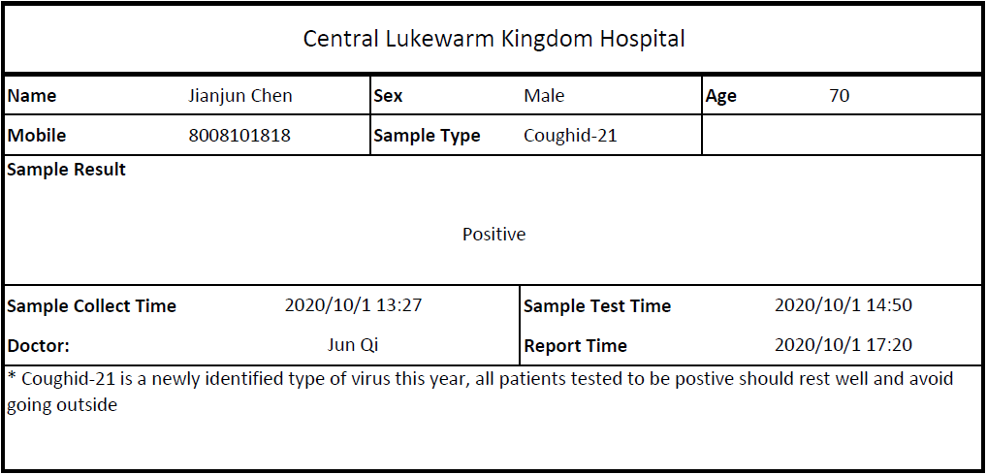

Please write down the detailed normalisation process for the viral test report. Firstly, identify all attributes you can find in the viral test report as well as in the specifications (you need to add your own attributes if your database design has them). Then, at each normalisation stage, list all functional dependencies and normalise them to the higher normal form. 3NF is required for the final tables and must match your ER diagram.

**Stage 1**

**Attributes**: Patient’s mobile phone number, Sample type, Description

**FDs (Indicate partial or transitive dependencies)**: In the movement from 0NF to 1NF, the patient's phone number and sample type form the union primary key. Since the sample type alone can determine the sample description, there is a partial dependency between the union primary key and the description.

**Normalised tables and which normal form they are currently in**: The sample type and description are separated from the patient table because of partial dependencies on the union primary key. At this point, both the ‘Patients’ table and the ‘Sample_Type_Detail’ table have separate primary keys and neither table has transitive dependency. Both tables satisfy the third normal form.

**Stage 2**

**Attributes**: Patient’s mobile phone number, doctor’s name, hospital

**FDs (Indicate partial or transitive dependencies)**: The three attributes above have transitive dependency because the patient’s mobile phone number is m-to-1 relative to the doctor’s name and hospital.

**Normalised tables and which normal form they are currently in**: Since the patient's cell phone number determines the doctor's name, the doctor's name determines the hospital in which he works. Patient cell phone numbers and doctor names are determinants. So separate patients' cell phone numbers from doctors and hospitals. Since there is still a many-to-one relationship between the doctor's name and the hospital's name, an additional table is built to store and count the hospital's name. In this way the ‘Patients’ table, ‘Doctor_information’ table and ‘Hospital’ table all meet the requirements of the third normal form.

# Use Cases

Remember to put all of your SQL statements into the SQL script file, including all SELECT statements and INSERT statements used to insert test data.

## Important Use Cases

This section lists some very important use cases of the PMMS. Your database design is expected to satisfy all of these use cases. Keep in mind that all use cases below should be achieved with a single SELECT statement (unless specified otherwise, sub-queries in a query is not counted as another query). Do not ignore the “explanation” or “proof” parts of this section, as they constitute the majority of your marks. If the SQL keywords/functions you learned cannot achieve these tasks, you are allowed to self-study some other keywords and use them. The example below is very simple and requires a short paragraph of explanation. But your answers should be more detailed.

------ The Beginning of the Example ------

***Use case 0***: Write a query to list all staff members in ‘B007’. In the result, list staff names.

Your SQL statement:

SELECT staff_name FROM staff NATURAL JOIN branch where branch.branch_no = 'B007'

Test data and explanation:

The following staff member information is added to the staff table (some attributes are hidden as they are not related to this task)

|  |  |
| --- | --- |
| Staff_name | Branch_no |
| ‘Jason’ | ‘B007’ |
| ‘Anna’ | ‘B002’ |
| ‘John’ | ‘B007’ |

The corresponding branch numbers ‘B007’ and ‘B002’ have already been added to the branch table.

This test data set contains staff members that are in ‘B007’ and not in ‘B007’. The expected result of the query should only contain staff in ‘B007’. Staff in other branches should be properly filtered out. For this test to work, all existing data in staff and branch need to be deleted first.

The result of the SELECT statement (screenshot):

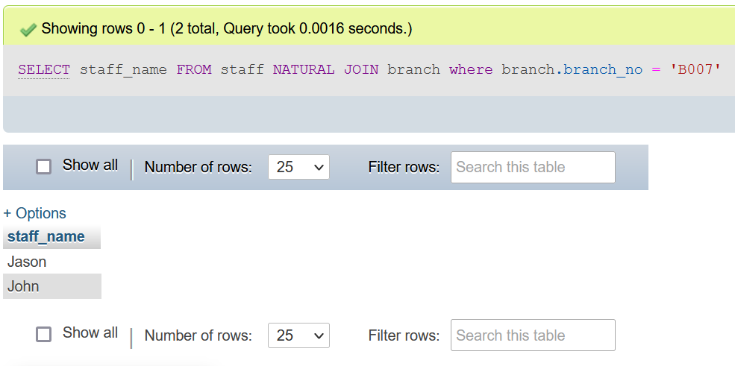

Both the SQL statement and results must appear in the same screenshot!

------ The End of the Example ------

All the cases are selected by Navicat

Use case 1: A person can potentially get infected if he was in the same district with someone. The government requires that, if someone is tested to be positive, all people in the same district as him in the past 48 hours (before the positive report is published) need to take viral tests. Assume that a person called Mark was tested to be positive at 19:30 on 09-Oct-2021. Mark’s telephone number is 233636. Please write a query that can get the phone numbers of all citizens who will potentially get infected because of him.

Your SQL statement:

SELECT DISTINCT SIM_ID FROM BS WHERE LEFT(GPS,2) IN (SELECT LEFT(GPS,2) FROM BS

WHERE SIM_ID='233636')AND SIM_ID!='233636'AND

(Out_time IS NULL OR TIMESTAMPDIFF(HOUR,Out_time,'2021-10-09 19:30:00')<48 AND TIMESTAMPDIFF(HOUR,Out_time,'2021-10-09 19:30:00')>0)

Your test data and why it can prove that the SELECT statement works (Important! Please explain carefully):

First, the nested SELECT statement filters out where an infected person has been based on his or her SIM_ID. The purpose of using the left function is to remove information irrelevant to the GPS number and location (that is, only the first two digits of the GPS code are needed). The external SELECT statement then looks up the SIM_ID from the base station table of people who passed through the same area as the infected person in the last 48 hours(Distinct is used to delete duplicate data). The judgment conditions are as follows: SIM_ID is not equal to that of the infected person, the time to leave the area passed by the infected person is empty (that is, he has been in the infected area), or the time to leave the area passed by the infected person is less than 48 hours from the reported time of the infected person (TIMESTAMPDIFF function is used to calculate the time here). The above methods can effectively screen out valid SIM_ID.

My test data are as follows: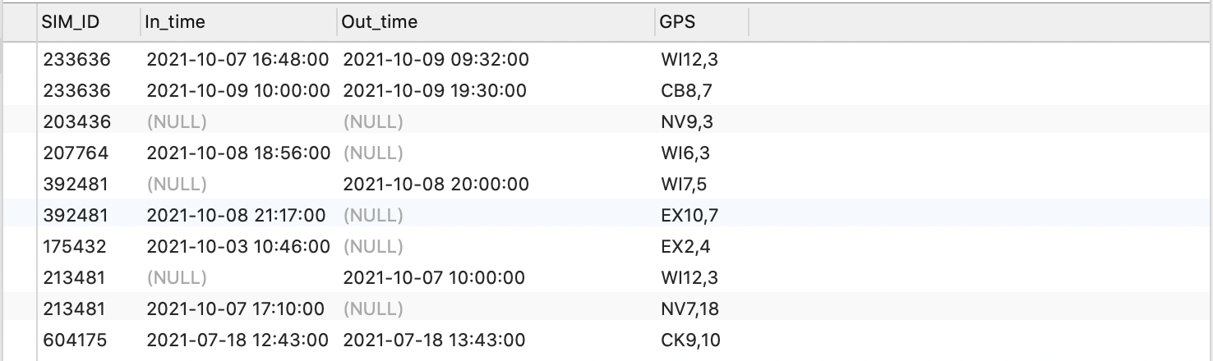

As a result, two people are infected and their SIM_ID is output.

The result of the SELECT statement (screenshot):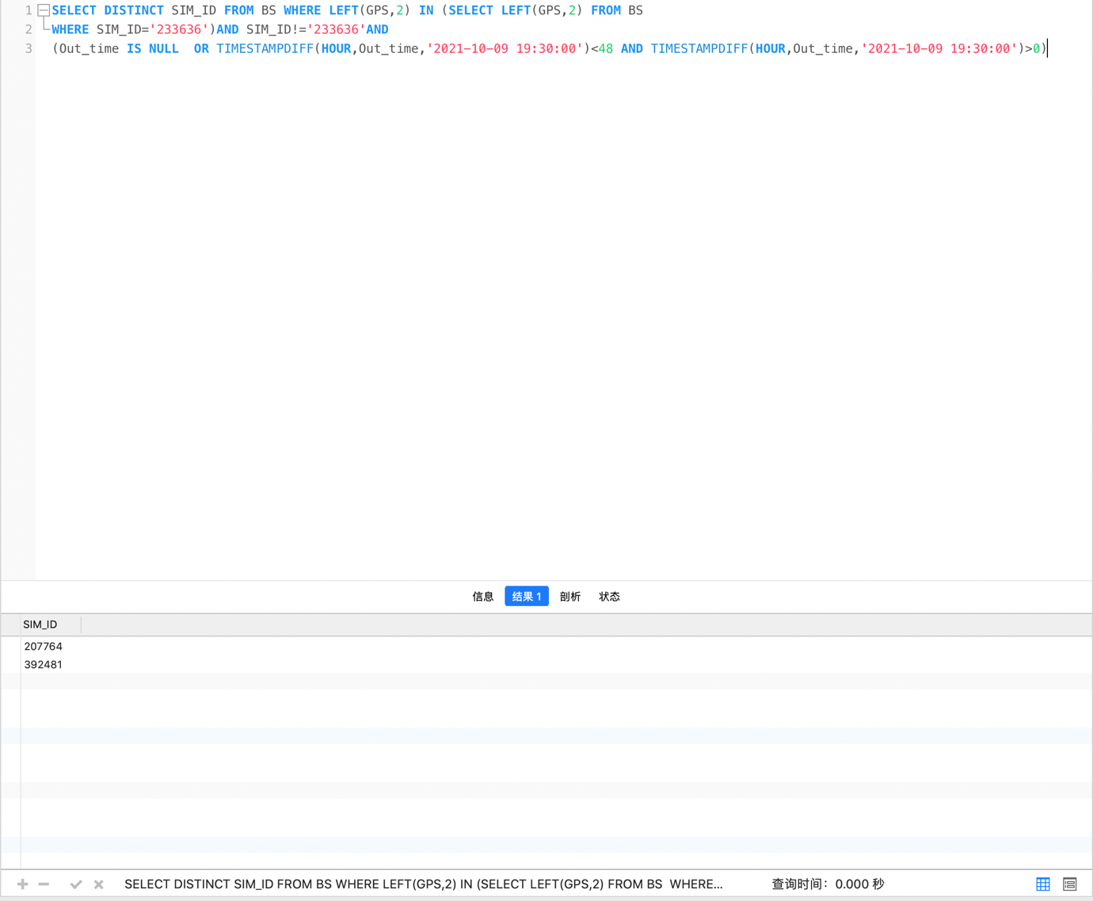

Use case 2: Please first clearly describe the format of GPS locations. The format must be a valid format that is used in real life. Then mimic what happens to your database when a user moves into the range of a base station and then moves out one hour later by listing all SQL statements involved in the process.

The GPS format and where did you learn it from (show the website link or the screenshot of the book):

As we all know, traditional GPS positioning uses "four-star positioning", in which the signal regions of the first two satellites intersect to form a plane, which in turn intersects the signal regions of the third satellite (sphere) at two points. Finally, the fourth satellite is used to determine which of the two points the target position is. Since GPS is used to locate the base station in Coursework, it is clear that the base station will not fly. We can simplify it to the location of a point in a two-dimensional plane. Since there are five regions in the Lukewarm kingdom, I named them with the first letter of the location, namely 'N', 'S', 'E', 'W' and 'C'. Then I take the northern region as an example. Since there are multiple districts in one area, I numbered them with another letter (case sensitive, capital and lower case for different districts). For example, the first district in the northern region is named 'NA' and the third district in the southern region is named 'SC'. This gives each district a unique number. This is the form of the ‘GPS’ column used as the primary key in the ‘District’ table. Since a district can contain multiple base stations, the district number alone is obviously not enough. According to the principle of "four-star positioning", when a plane (i.e. a district) is determined, the exact position can be determined according to the positioning of the other two satellites. Thus, the location of a base station can be uniquely determined by adding the numbers of the two satellites that determine the exact location to the name of the district. In summary, the name of each base station can be determined by the district code plus the two satellite numbers. This location mode is relatively simple and practical for the two-dimensional plane. Additionally, it is convenient for query and comparison.

（Website link：<https://wenku.baidu.com/view/4e7eed11185f312b3169a45177232f60dccce778.html>）

Your SQL statement(s) for travel record insertion:

INSERT INTO `cw3`.`Person` (`SIM_ID`, `Name`) VALUES ('667788', 'Tom')

INSERT INTO `cw3`.`BS` (`SIM_ID`, `In_time`, `Out_time`, `GPS`) VALUES ('667788', '2021/7/18/12:43', '2021/7/18/13:43', 'CK9,10')

The result of the SELECT statements (screenshot): 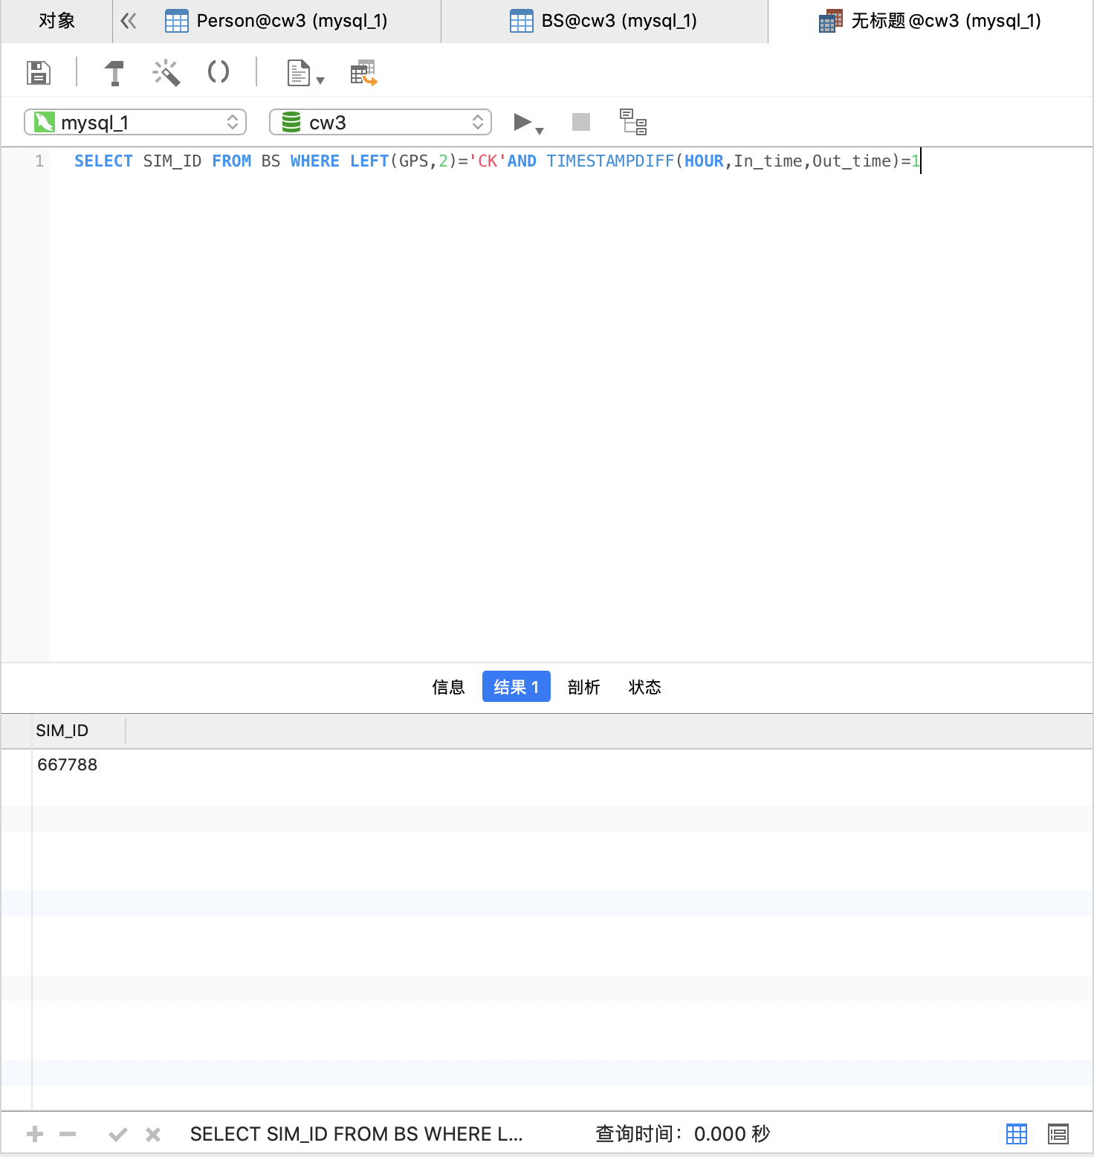

Use case 3: The Lukewarm Kingdom wants to find out the hospitals that can do viral tests efficiently. The report generation time is calculated using (report time - sample test time). Please write a query to find out which hospital has the least average report generation time.

Your SQL statement:

SELECT H_Name FROM Hospital INNER JOIN (SELECT H_Number,result.AVG_H from

(SELECT H_Number,avg(TIMESTAMPDIFF(MINUTE,Test_Time,Report_Time)) AS AVG_H FROM Time GROUP BY H_Number)result

WHERE result.AVG_H IN (SELECT MIN(result.AVG_H) AS Useful_H FROM (SELECT H_Number,avg(TIMESTAMPDIFF(MINUTE,Test_Time,Report_Time))AS AVG_H FROM Time GROUP BY H_Number)result))Result USING(H_Number)

Your test data and why it can prove that the SELECT statement works (Important! Please explain carefully):

In this SQL statement, the internal select uses the TIMESTAMPDIFF and AVG functions to differentiate and average the report and test times. The effect of GROUP BY is to classify the average by hospital. Name the derived table from these steps' result '. The external select is then used to find the minimum value in the mean column of the 'result' table and output the corresponding hospital code. The derived table is now named 'Result'. Finally, use a select on the outermost part and INNER JOIN the 'Result' and 'Hospital' table through 'H_Number' to find the name of the Hospital that meets the requirements.

My test data are as follows: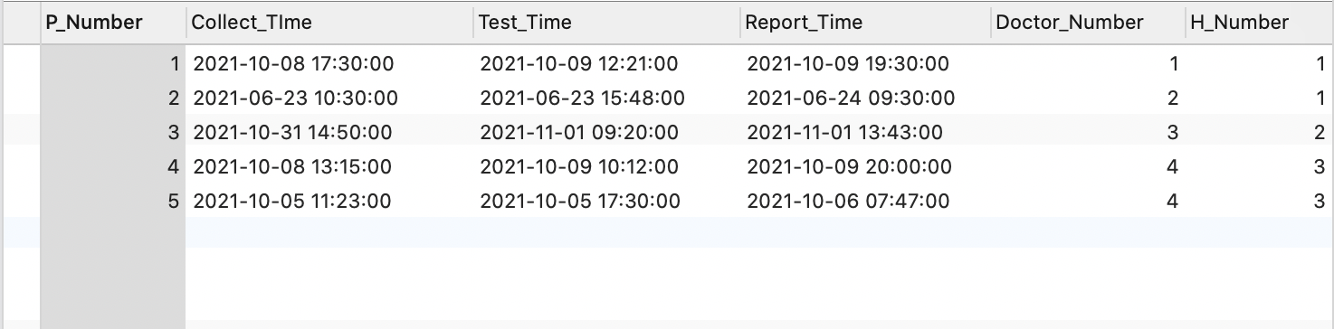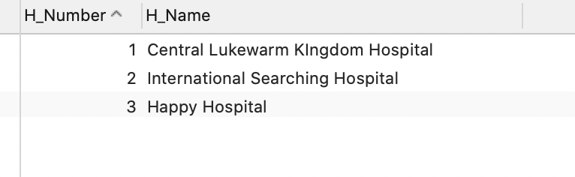

There were multiple cases tested at different hospitals at different times. One hospital ended up with the shortest test time.

The result of the SELECT statement (screenshot):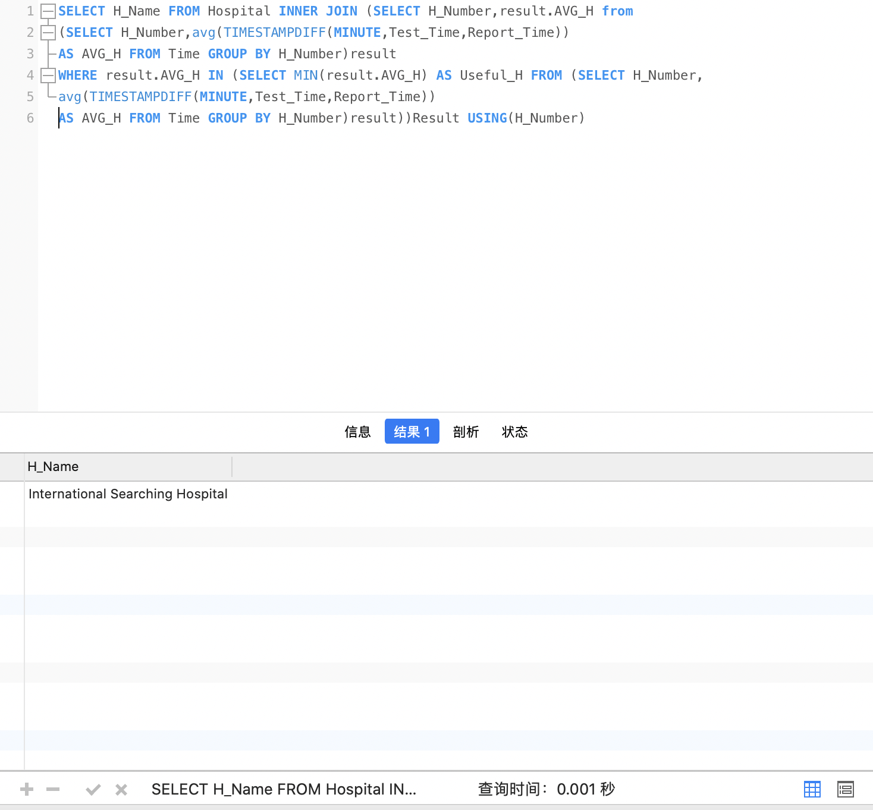

Use case 4: List the phone numbers of all citizens who did two viral tests with the time window from 2021-10-03 00:00 to 2021-10-05 00:00. The two viral tests must have a gap time of at least 24 hours (at least 24 hours apart).

Your SQL statement:

SELECT P_Mobile FROM Patients WHERE P_Number IN (SELECT Result_1.P_Number FROM Time,(SELECT P_Number,Collect_TIme FROM Time AS Result_1 WHERE P_Number IN (SELECT P_Number FROM Time WHERE TIMESTAMPDIFF(HOUR,'2020-10-3-0:00',Collect_TIme)>=0

AND TIMESTAMPDIFF(HOUR,'2020-10-3-0:00',Collect_TIme)<=48 GROUP BY P_Number HAVING COUNT(*)=2))Result_1 WHERE Time.P_Number=Result_1.P_Number AND ABS(TIMESTAMPDIFF(HOUR,Result_1.Collect_TIme,Time.Collect_TIme)>=24))

Your test data and why it can prove that the SELECT statement works (Important! Please explain carefully):

Firstly, the COUNT statement and TIMESTAMPDIFF function are used to filter out the number and corresponding testing time (Collect_TIme instead of Test_Time) of the people tested twice from October 3rd to October 5th in the ‘Time’ table and name it as' Result_1 'table. The absolute value function and TIMESTAMPDIFF function are used to determine whether the two testing times are 24 hours apart by comparing the testing time in the 'Time' table with ‘P_Number’ equal. Finally, the patients whose numbers were the same as those found in the above steps were searched from the ‘Patients’ table and their ‘SIM_ID’ was output.

I've listed three patients. No.6 was tested twice between October 3rd and October 5th with an interval of more than 24 hours. No.7 was also tested twice, but only once was between October 3rd and October 5th. No. 8 had been tested twice from October 3 to October 5 but the interval was less than 24 hours.

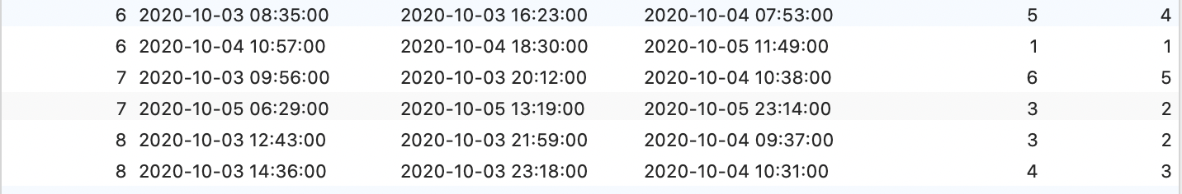

The last column of the graph below shows the SIM card ids of the three

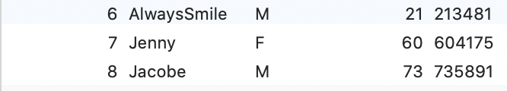

The result of the SELECT statement (screenshot):

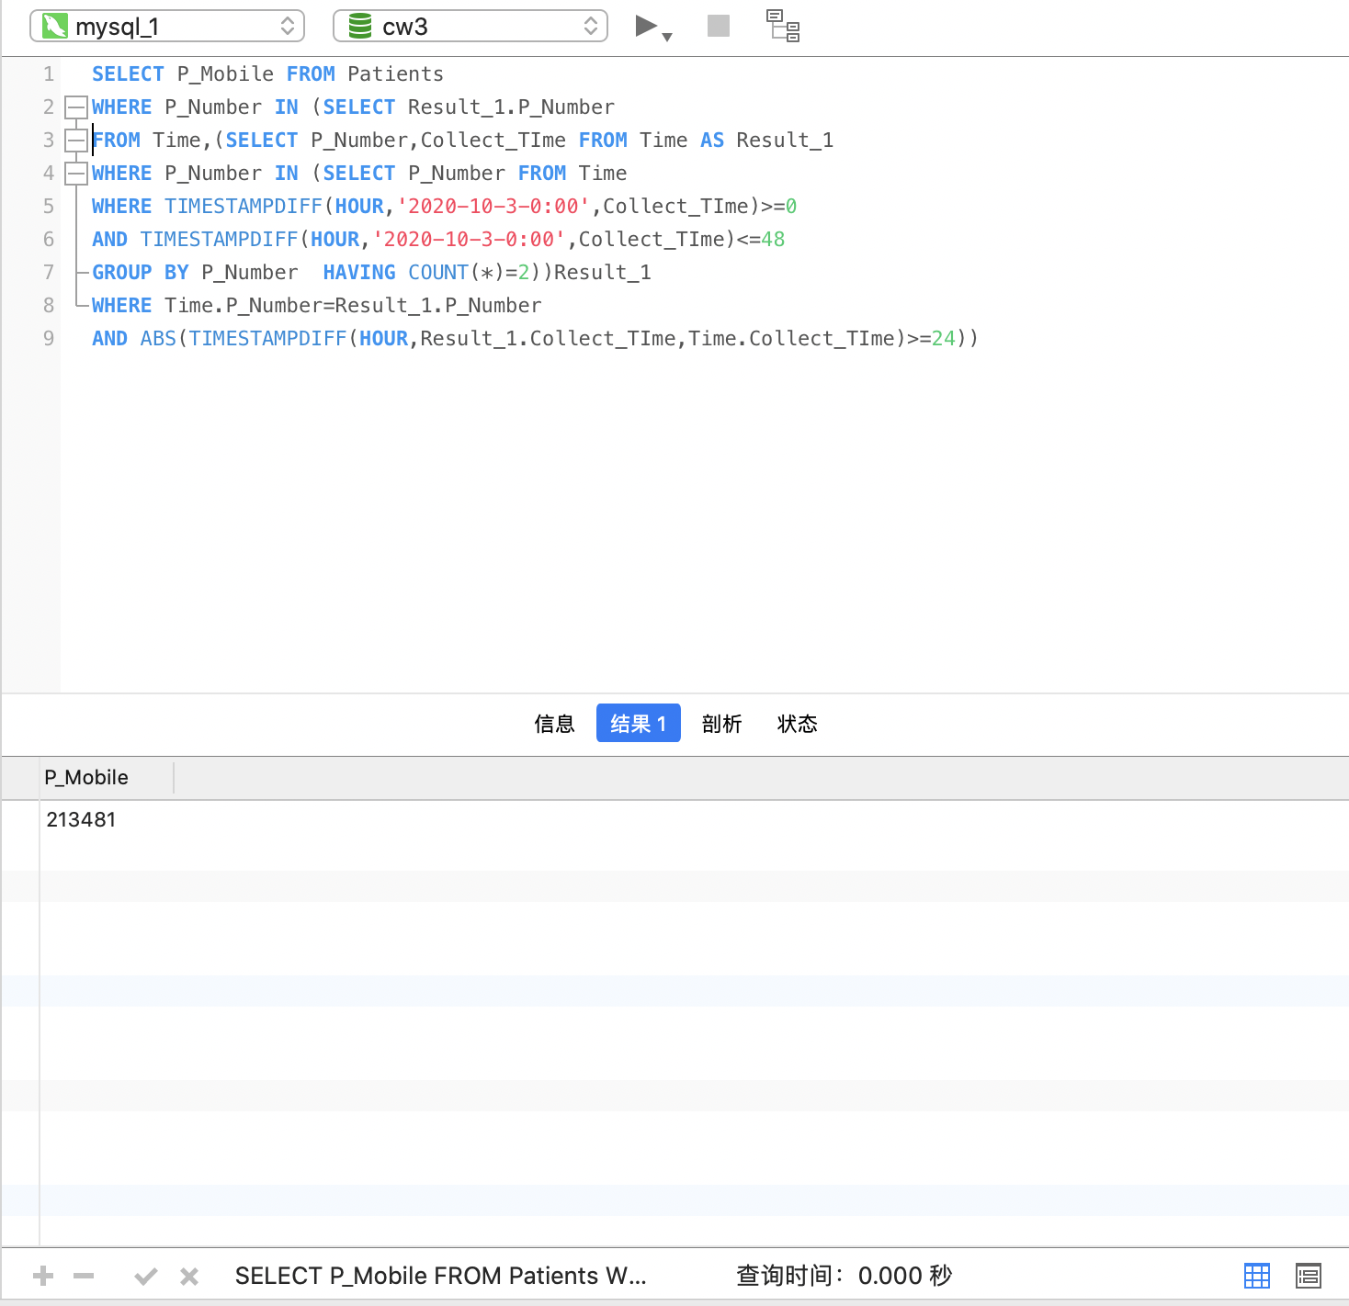

Use case 5: List the high-risk, mid-risk and low-risk districts using one query. High-risk districts should be listed first, followed by mid-risk districts and then low-risk districts. Example:

|  |  |
| --- | --- |
| **district_name** | **risk_level** |
| Centre Lukewarm Hillside | high |
| Lenny town | high |
| Glow Sand district | mid |
| Raspberry town | low |
| Bunny Tail district | low |

Your SQL statement:

SELECT DISTINCT District_Name AS district_name, risk_level FROM District ORDER BY CASE risk_level WHEN 'high' THEN 1 WHEN 'mid' THEN 2 ELSE 3 END

(I executed two UPDATE statements before the SELECT statement to adjust the risk level of the affected districts. The two UPDATE statements are listed below:

UPDATE District SET risk_level='high' WHERE GPS IN (SELECT LEFT(GPS,2) FROM BS WHERE SIM_ID IN(SELECT P_Mobile FROM Patients WHERE P_Number IN (SELECT P_Number FROM Sample_Type WHERE Sample_Result='P')AND TIMESTAMPDIFF(HOUR,BS.In_time,BS.Out_time)>=24));

UPDATE District SET risk_level='mid' WHERE GPS IN (SELECT LEFT(GPS,2) FROM BS WHERE SIM_ID IN(SELECT P_Mobile FROM Patients WHERE P_Number IN (SELECT P_Number FROM Sample_Type WHERE Sample_Result='P')AND TIMESTAMPDIFF(HOUR,BS.In_time,BS.Out_time)<24));

The result of the SELECT statement (screenshot):

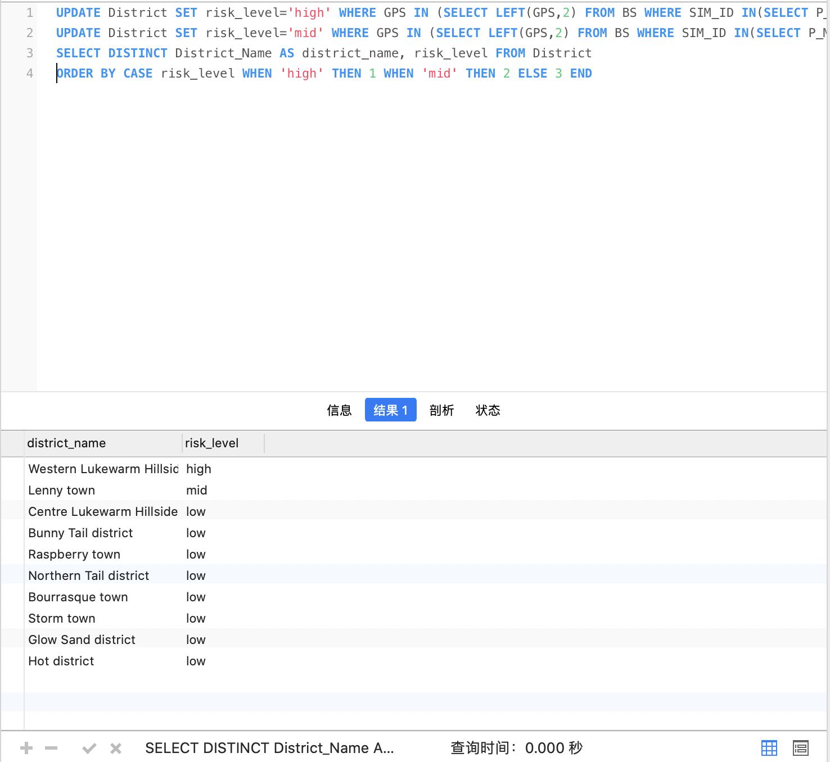`

Use case 6: List all positive cases found in the district called “Centre Lukewarm Hillside” on 2021-10-04. The result should include the names and phone numbers of people tested to be positive.

Your SQL statement:

SELECT P_Name,P_Mobile FROM Patients WHERE P_Number IN

(SELECT DISTINCT P_Number FROM Time WHERE

Report_Time>='2021-10-4-00:00' AND Report_Time<'2021-10-5-00:00' AND H_Number IN

(SELECT H_Number FROM Hospital WHERE GPS='CK'))

Your test data and why it can prove that the SELECT statement works (Important! Please explain carefully):

The ‘H_number’ at Centre Lukewarm Hillside was screened from the ‘Hospital’ table and the number of patients tested at the newly screened hospital on October 4th was screened from the time table. Finally, patients' names and mobile phone numbers were screened from the ‘Patients’ table according to their numbers.

The test data are listed below:

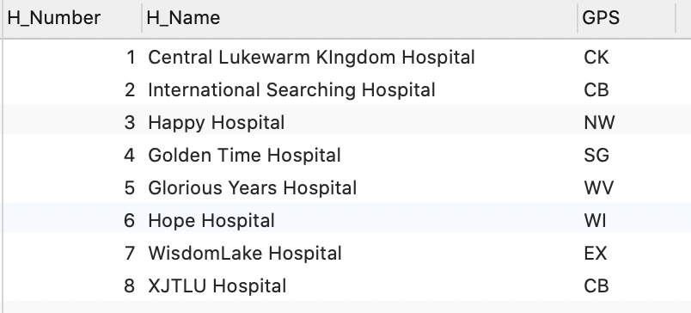

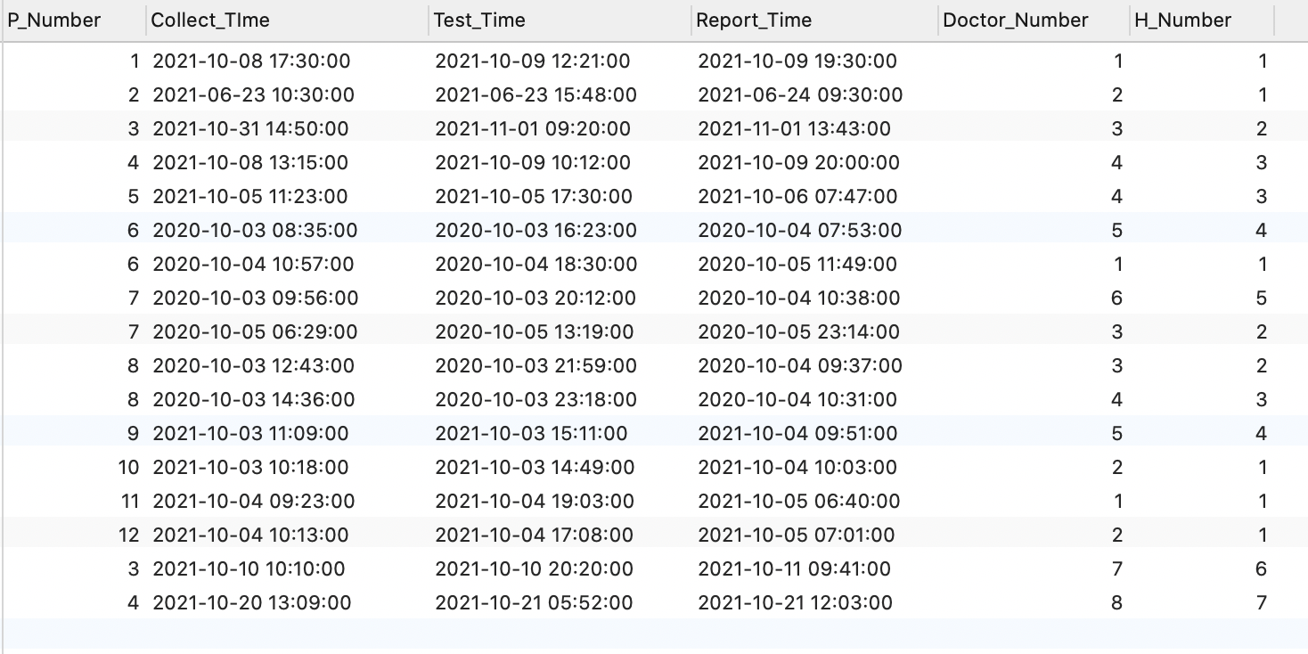

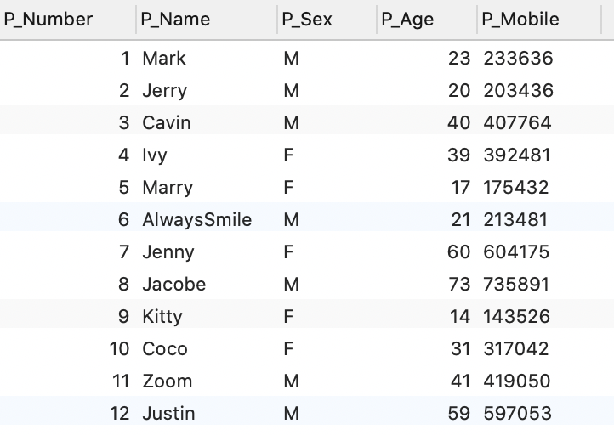

The result of the SELECT statement (screenshot):

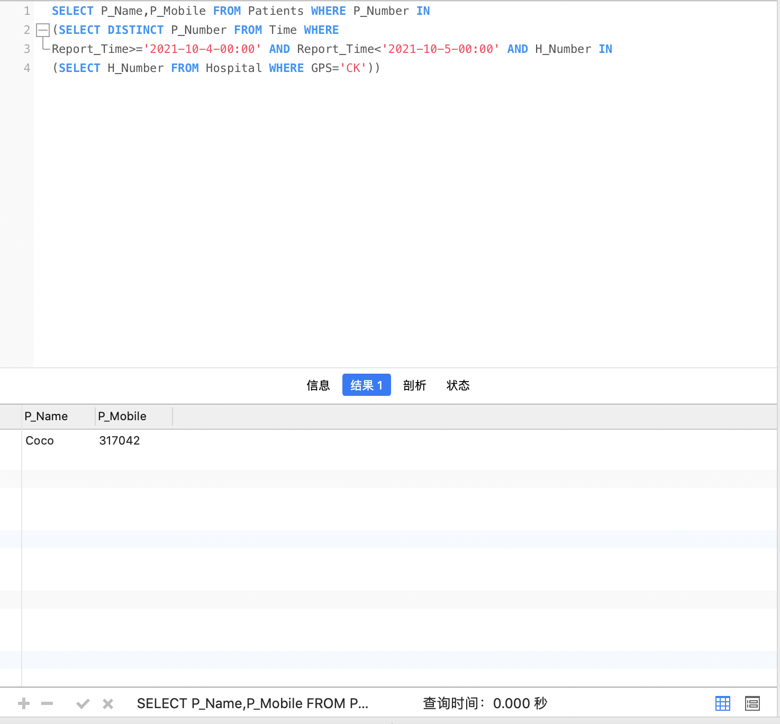

Use case 7: Calculate the increase in new positive cases in the district called “Centre Lukewarm Hillside” on 2021-10-05 compared to 2021-10-04. The result should show a single number indicating the increment. If there are fewer new positive cases than yesterday, this number should be negative.

Your SQL statement:

SELECT (SELECT COUNT(DISTINCT P_Number)FROM Time WHERE

Report_Time>='2021-10-5-00:00' AND Report_Time<'2021-10-6-00:00' AND H_Number IN

(SELECT H_Number FROM Hospital WHERE GPS='CK'))-(SELECT COUNT(DISTINCT P_Number)FROM Time WHERE

Report_Time>='2021-10-4-00:00' AND Report_Time<'2021-10-5-00:00' AND H_Number IN

(SELECT H_Number FROM Hospital WHERE GPS='CK'))AS 'increase_number'

Your test data and why it can prove that the SELECT statement works (Important! Please explain carefully):

The screening idea of this case is basically the same as that of the previous case. First, the number of patients confirmed on October 4 and confirmed on October 5 were selected through the COUNT statement. Use a SELECT statement on the outside to multiply the two, and name the result 'increase_number'.

My test data is listed below:

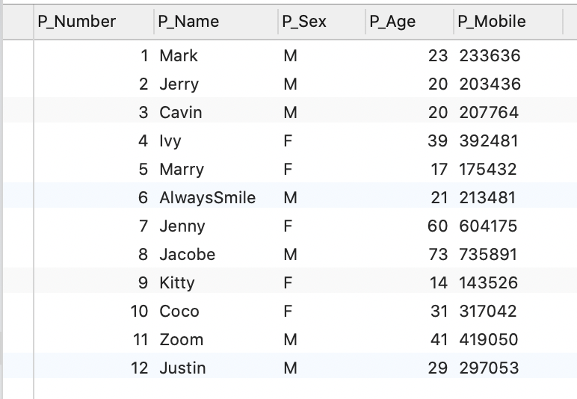

I assume that patients 11 and 12 tested positive on October 5, and patient 10 tested positive on October 4. So that the increment is 1. When I removed patients 11 and 12 respectively, the results will change into 0 and -1 step by step.

The result of the SELECT statement (screenshots):

When the number of patients on October 5th is the same as on October 4th:

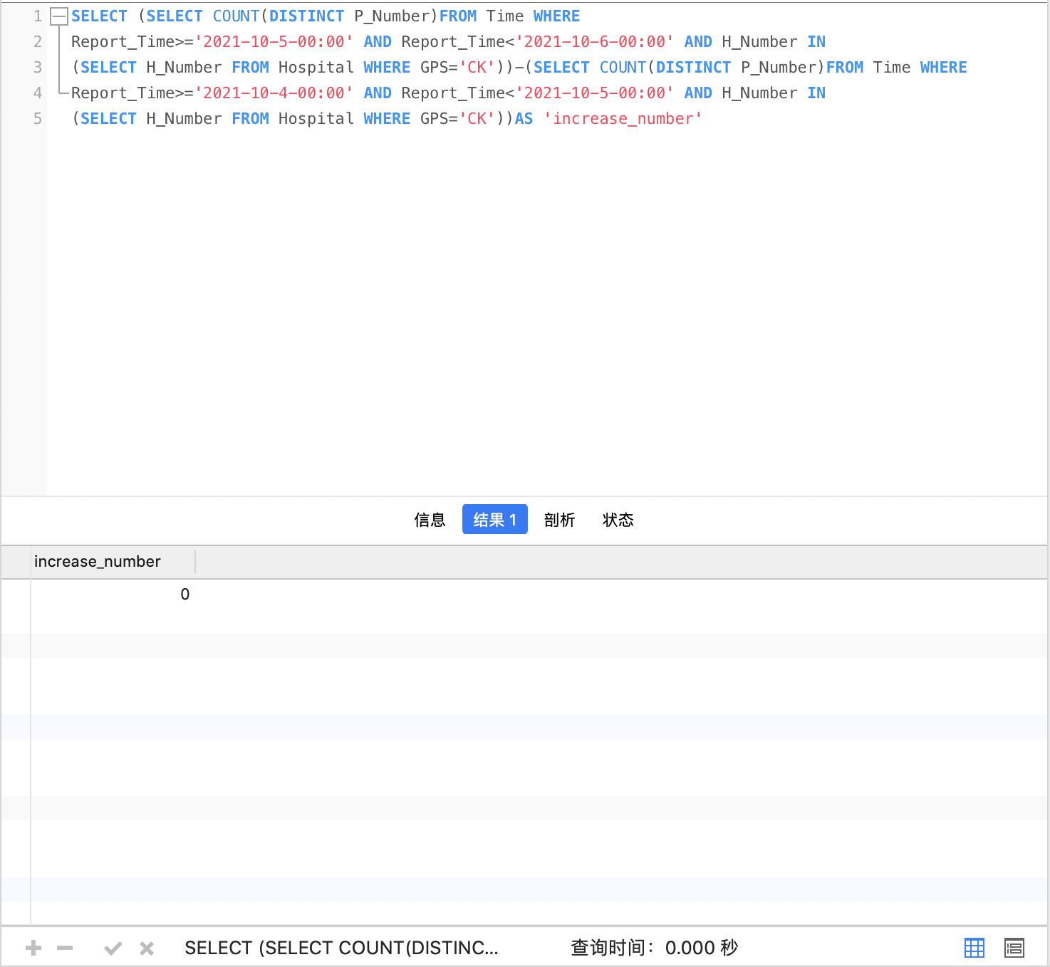

When the number of patients on October 5th is less than on October 4th:

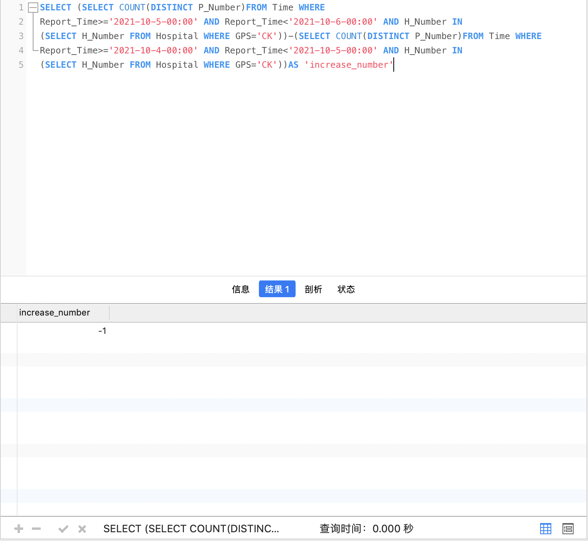

When there are more patients on October 5th than on October 4th:

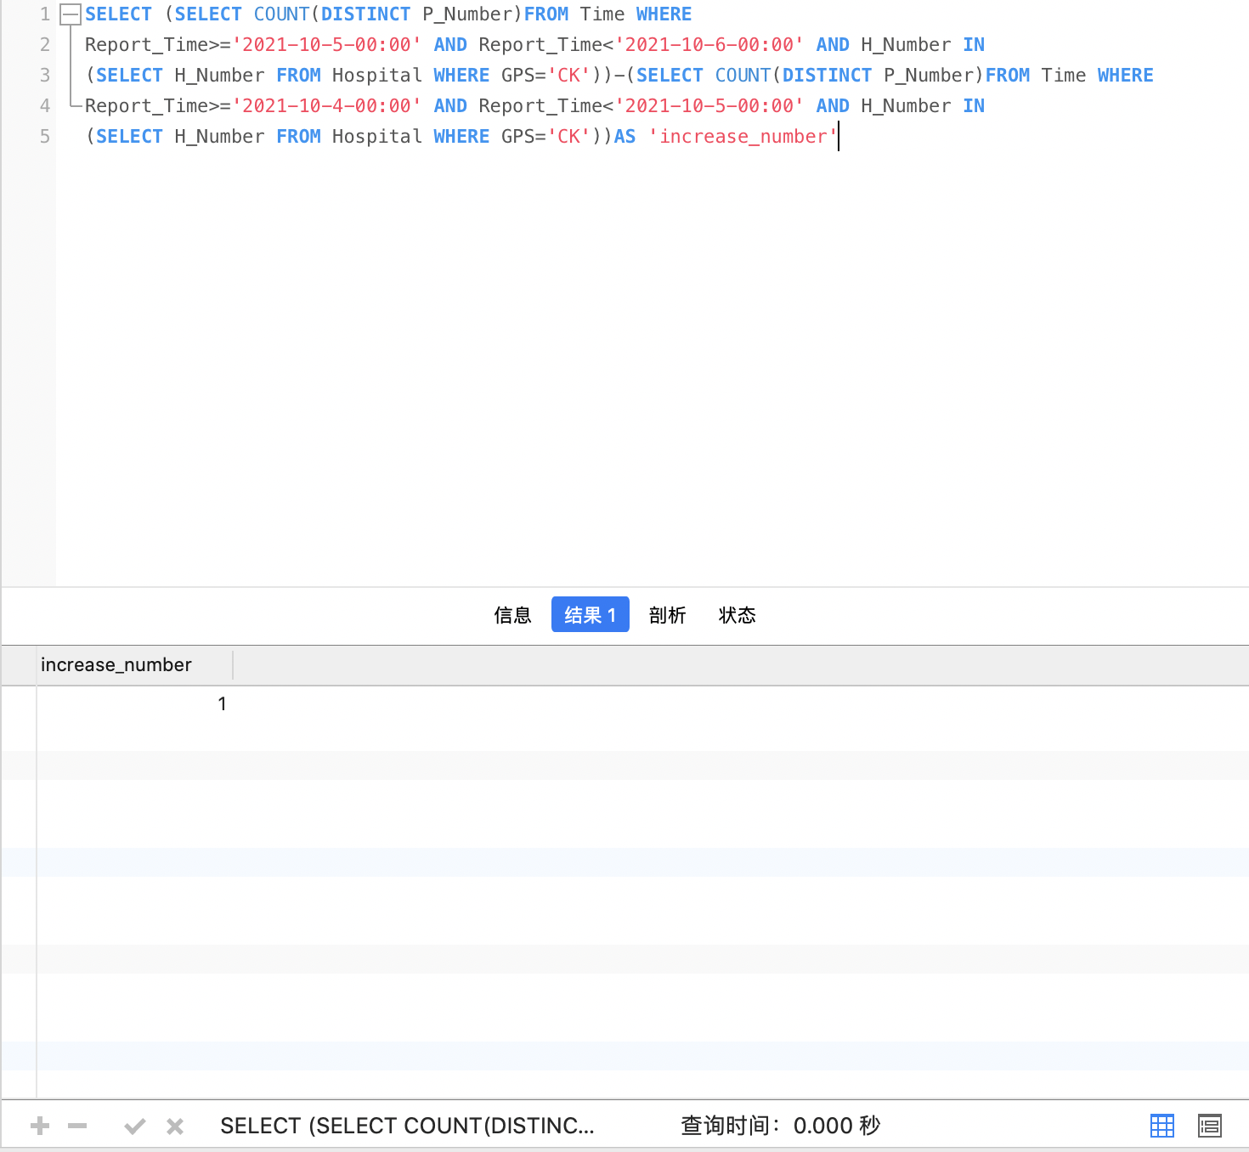

Use case 8: Assume that the spread rate of a virus is calculated by dividing the total number of people that were in the same district as the positive case with 48 hours (calculated in use case 1) by the total number of people among them that later confirmed to be infected in 14 days. Again, assume that a person called Mark (telephone number is 233636) was tested to be positive at 19:30 on 09-Oct-2021 and he is the only person in the country that has coughid-19. Please write a query that calculates the spread rate of the virus.

Your SQL statement:

SELECT (SELECT count(result_2.P_Number) AS infected FROM

(SELECT P_Number FROM (SELECT DISTINCT SIM_ID FROM BS WHERE LEFT(GPS,2) IN (SELECT LEFT(GPS,2) FROM BS

WHERE SIM_ID='233636')AND SIM_ID!='233636'AND

(Out_time IS NULL OR TIMESTAMPDIFF(HOUR,Out_time,'2021-10-09 19:30:00')<48

AND TIMESTAMPDIFF(HOUR,Out_time,'2021-10-09 19:30:00')>0))result_1,Patients

WHERE result_1.SIM_ID=Patients.P_Mobile)result_2,Time,Sample_Type

WHERE result_2.P_Number=Time.P_Number AND Time.Report_Time>='2021-10-09-19:30'

AND Time.Report_Time<'2021-10-23-0:00'AND

result_2.P_Number=Sample_Type.P_Number AND Sample_Type.Type_Number='1'

AND Sample_Type.Sample_Result='P')/(SELECT count(DISTINCT SIM_ID) FROM BS

WHERE LEFT(GPS,2) IN (SELECT LEFT(GPS,2) FROM BS

WHERE SIM_ID='233636')AND SIM_ID!='233636'AND

(Out_time IS NULL OR TIMESTAMPDIFF(HOUR,Out_time,'2021-10-09 19:30:00')<48

AND TIMESTAMPDIFF(HOUR,Out_time,'2021-10-09 19:30:00')>0))AS spread_rate

Your test data and why it can prove that the SELECT statement works (Important! Please explain carefully):

(In this case, I temporarily changed the first item in the 'Sample_Type_Detail' table to Coughid-19)

Firstly, SELECT statement in Use Case 1 was used to screen out the number of people who had contact with Mark. Then determine the number of Patients who tested positive for Cough19 between October 9 and October 22 (this should be screened together in the 'Patients',' Time 'and' Sample_Type 'tables). Finally, use a SELECT statement to print out their ratios and name the column 'spread_rate'.

My test data is listed below:

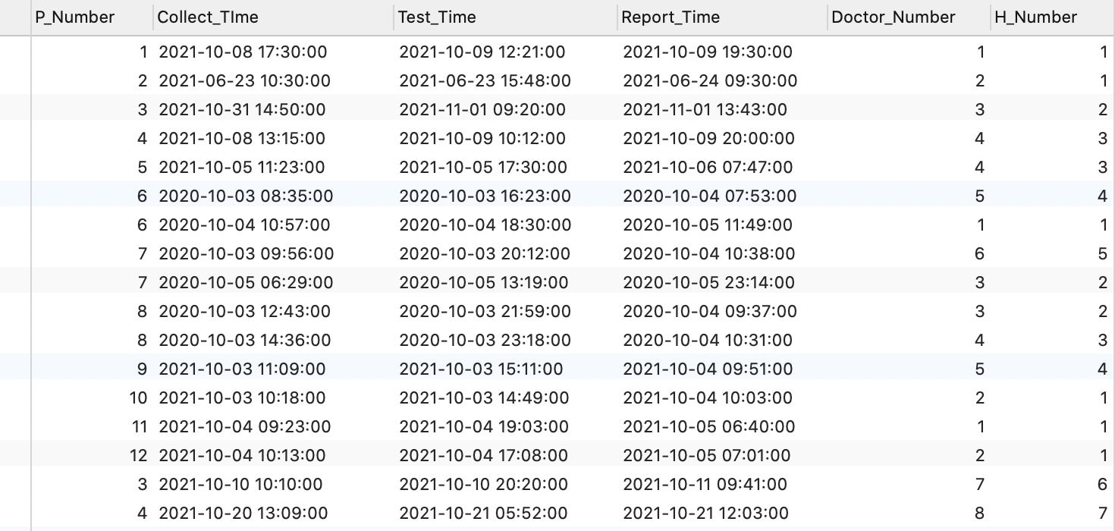

In Use Case 1, No. 3 and No. 4 were screened out as people who stayed in same district with Mark. Then I assumed that No. 3 tested positive within 14 days, and the final spread rate would be 0.5.

The result of the SELECT statement (screenshots):

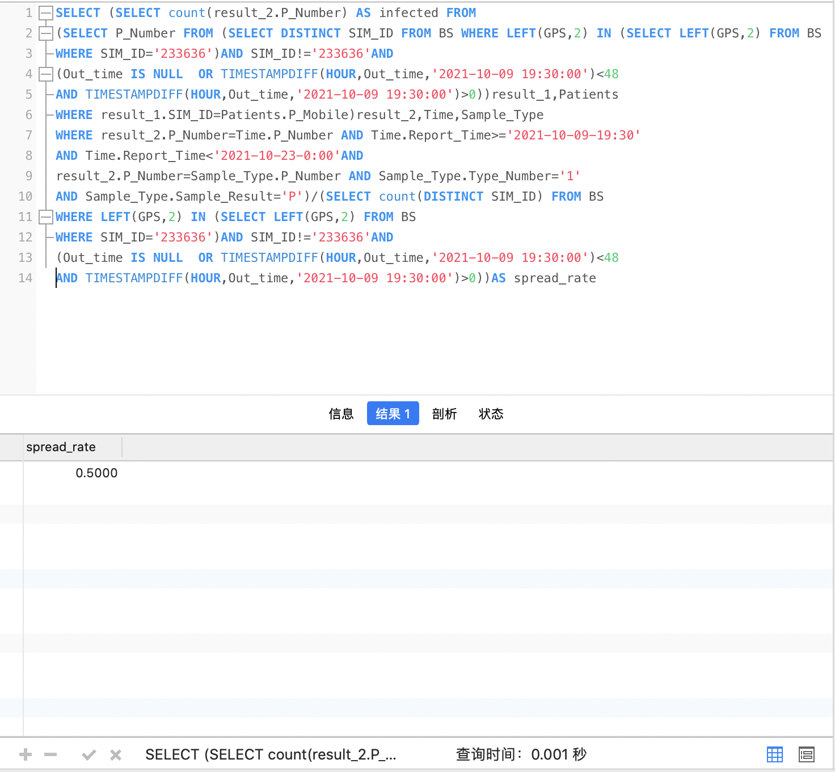

## Extended Use Cases

Apart from the use cases proposed in the previous section, your database could also support more scenarios. Please follow the same format in the previous section and write down your own 10 use cases. You are allowed to use keywords learned outside of the lectures. Practical use cases displaying good innovations will receive higher marks.

Use case 1: Staff testing now needs to be done at hospitals where positive patients are being treated or they’ve been. Write a query to determine which hospitals need to be tested.

Your SQL statement:

SELECT H_Name FROM Hospital WHERE H_Number IN

(SELECT H_Number FROM Book WHERE P_Number IN

(SELECT DISTINCT P_Number FROM Sample_Type WHERE Sample_Result='P'))

Your test data and why it can prove that the SELECT statement works (Important! Please explain carefully): The SELECT statement first finds the numbers of patients that test positive: 1, 3, 9, 10, 11, 12. Then compare the "Book" table to screen out the number of the hospital where they were tested: 1, 2, 4, 6. Finally, find the name of the corresponding Hospital from the 'Hospital' table.

The tables listed below are 'Sample_Type', 'Book', and 'Hospital':

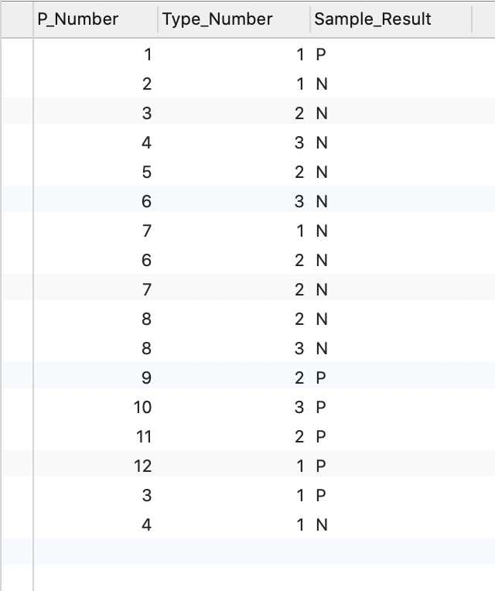

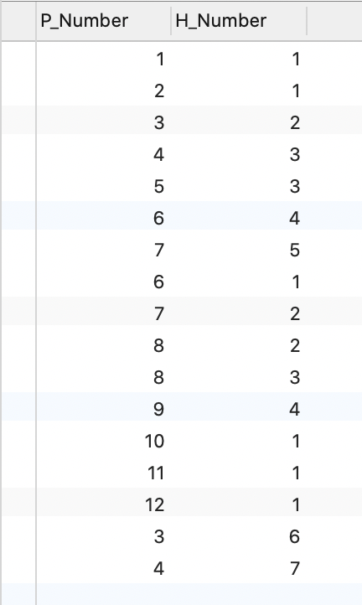

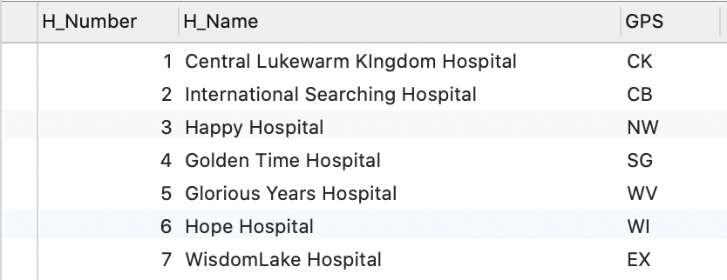

The result of the SELECT statement (screenshot):

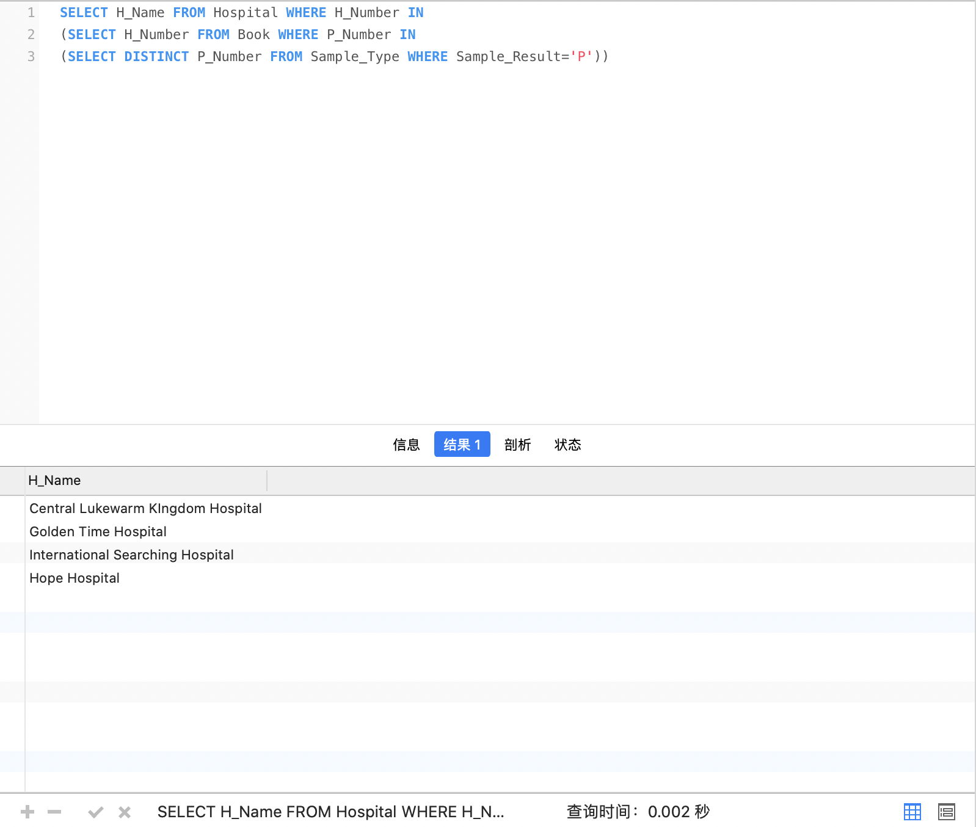

Use case 2: Please write a query for the names and cell phone numbers of all the patients who is tested by Lisa.

Your SQL statement:

SELECT DISTINCT P_Name,P_Mobile FROM Patients INNER JOIN Time USING (P_Number) WHERE Time.Doctor_Number=4

Your test data and why it can prove that the SELECT statement works (Important! Please explain carefully):

Use the INNER JOIN statement to find both the 'Time' table and the 'Patients' table under the condition that the doctor who tested the Patients was Doctor no. 4 (Lisa). The results of the query showed that three patients met the requirements. Finally output three patient names and mobile phone numbers, which is consistent with the requirements of the question.

The 'Time' table and 'Patients' table are listed below:

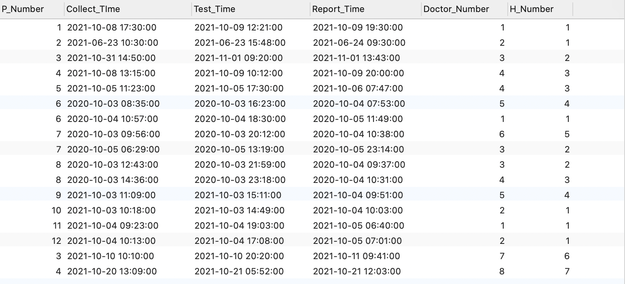

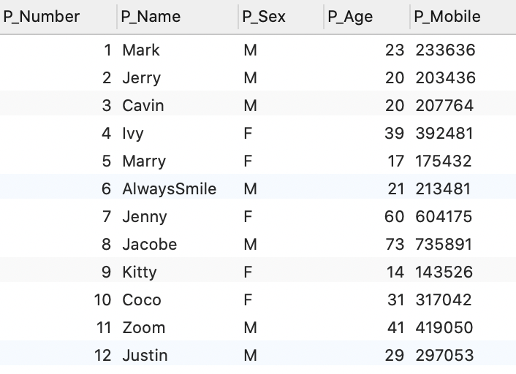

The result of the SELECT statement (screenshot):

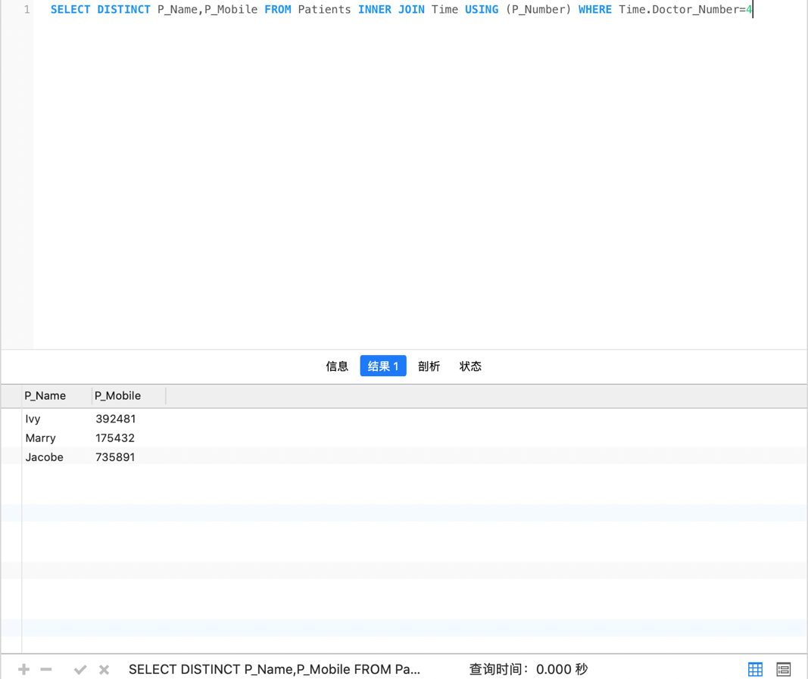

Use case 3: Please calculate the current coughid-21 infection rate (i.e. divide the number of people who test positive by the number of all registered cell phone numbers and names)

Your SQL statement:

SELECT (SELECT COUNT(P_Number) FROM Sample_Type WHERE Type_Number=1 AND Sample_Result='P')/(SELECT COUNT(SIM_ID) FROM Person) AS rate

Your test data and why it can prove that the SELECT statement works (Important! Please explain carefully):

Firstly, count the number of people in 'Sample_Type' (three patients tested positive for coughid-21). Then count the total number of people registered in the 'Person' table as 14. Finally, the probability is 0.2143 by diving 3 by 14.

The table ‘Sample_Type’ and ‘Person’ are listed below:

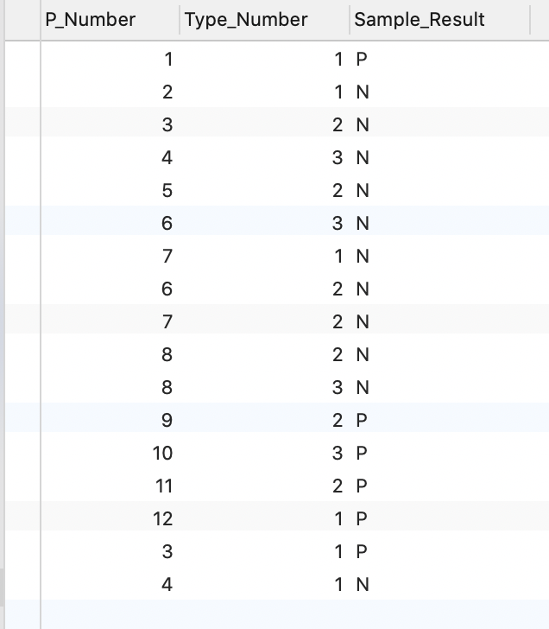

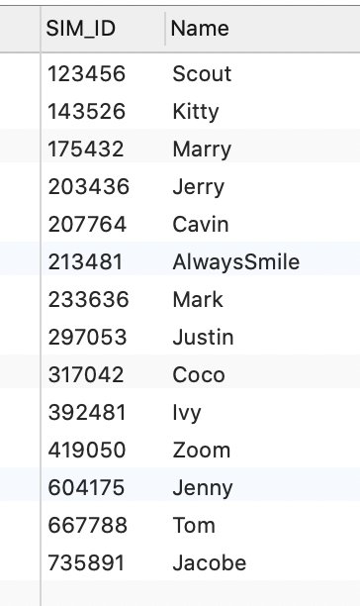

The result of the SELECT statement (screenshot):

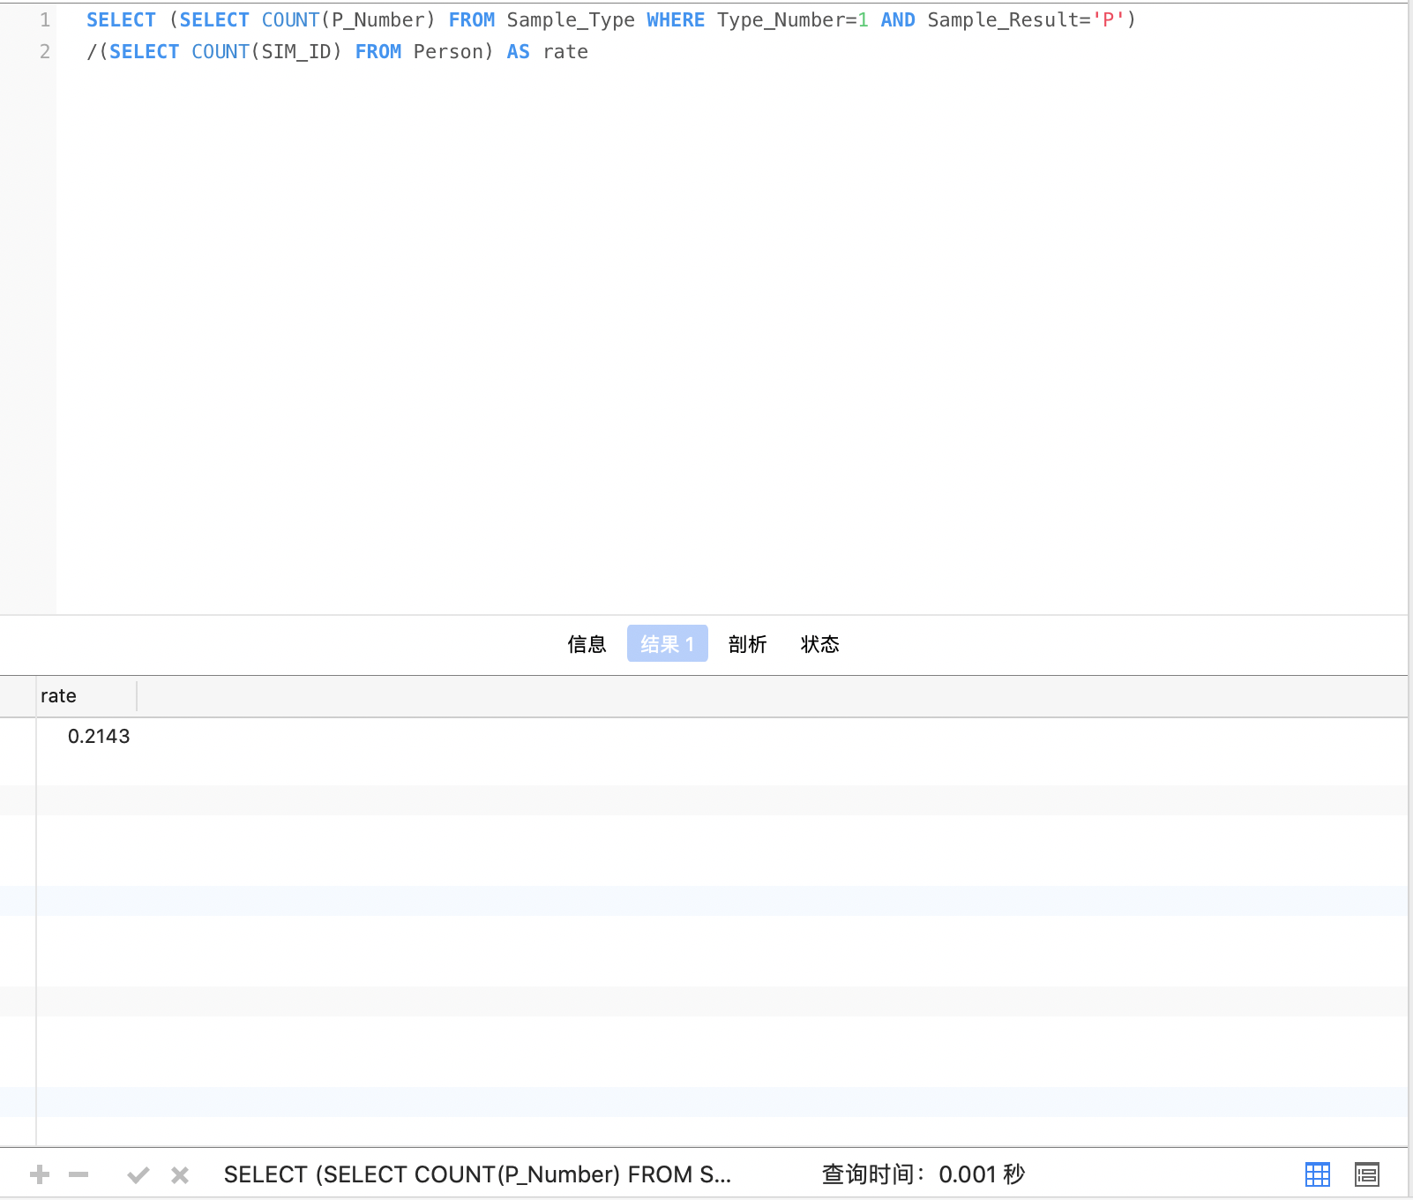

Use case 4: Arrange the 'Time' table in ascending order and place the hospital name and location on the right side of the table.

Your SQL statement: SELECT*FROM Time LEFT OUTER JOIN Hospital ON Time.H_Number=Hospital.H_Number ORDER BY P_Number ASC

Your test data and why it can prove that the SELECT statement works (Important! Please explain carefully): This example joins the 'Time' table with the 'Hospital' table using the LEFT OUTER JOIN, and then uses the ORDER BY statement to sort the table upward.

The ‘Time’ table and ‘Hospital’ table are listed below:

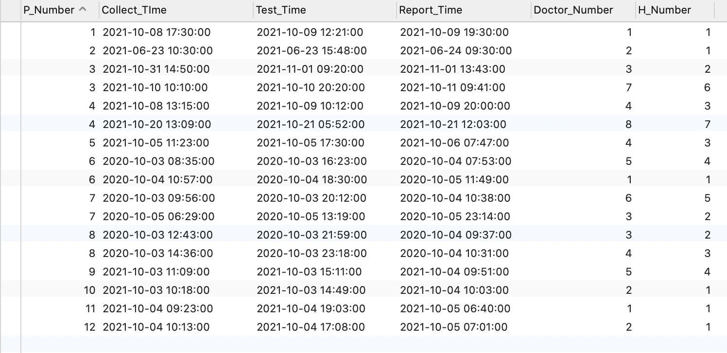

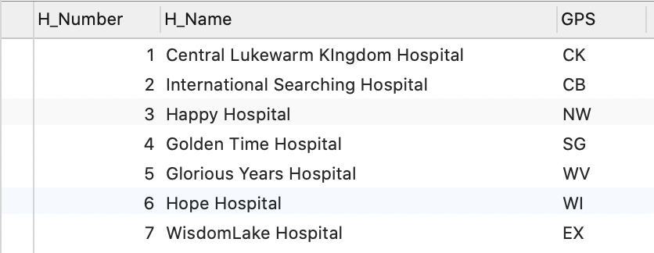

The result of the SELECT statement (screenshot):

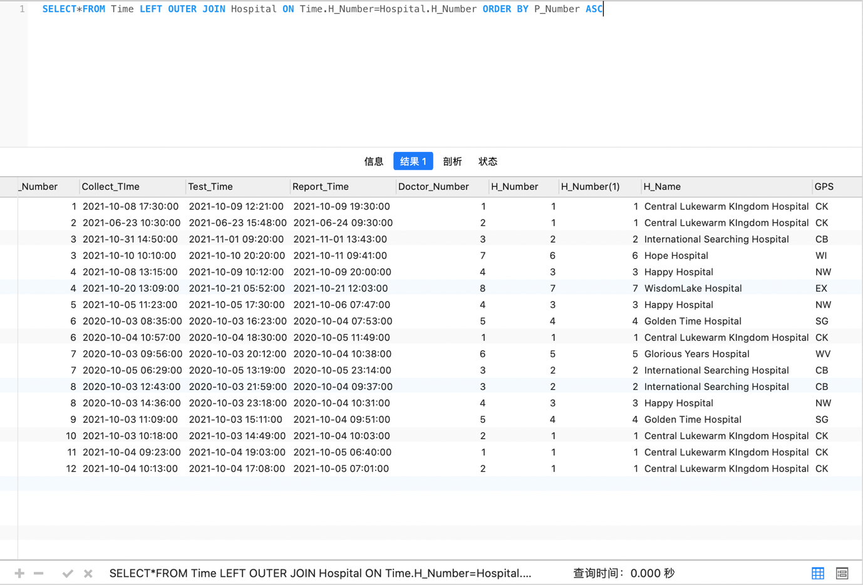

Use case 5: Please test whether a person named Steven (cell phone number 908762) has been tested.

Your SQL statement:

SELECT COUNT(*)AS Judgement FROM Patients WHERE P_Mobile='908762'

Your test data and why it can prove that the SELECT statement works (Important! Please explain carefully): Use the COUNT statement to traverse the 'Patients' table to see if there are rows in the P_Mobile column that match. A result of 0 indicates that no record was found for the mobile phone number 908762.

The ‘Patients’ table is listed below:

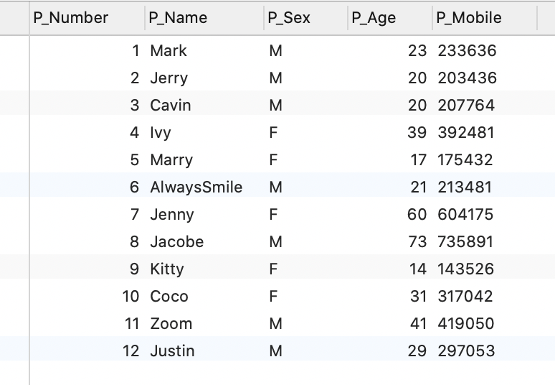

The result of the SELECT statement (screenshot):

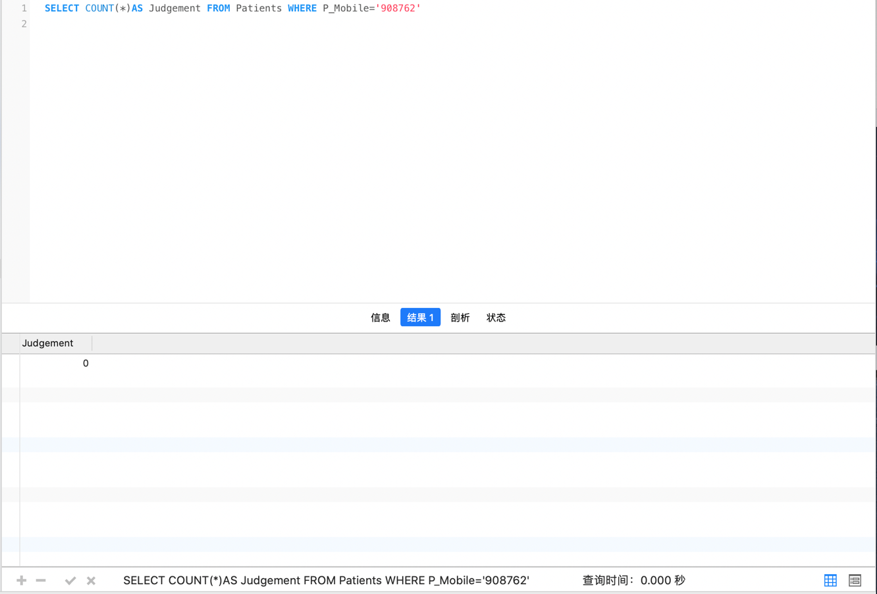

Use case 6: According to the study, Coughid-21 is more dangerous for older people. Therefore, please screen out the names and phone numbers of the oldest patients who have tested positive for Coughid-21 so that the hospital can focus on them.

Your SQL statement:

SELECT P_Name, P_Mobile FROM Patients

WHERE P_Age=(SELECT MAX(P_Age) FROM

(SELECT P_Name,P_Mobile,P_Age FROM Patients WHERE P_Number IN

(SELECT P_Number FROM Sample_Type WHERE Type_Number='1'AND Sample_Result='P'))result)

AND P_Number IN(SELECT P_Number FROM Sample_Type WHERE Type_Number='1'AND Sample_Result='P')

Your test data and why it can prove that the SELECT statement works (Important! Please explain carefully):

From the "Sample_Type" table, three patients, no. 1, no. 3 and No. 12, could be screened out as positive for Coughid-21. A SELECT statement is then used to filter out the oldest of the three (age 29) to print the final result.

The ‘Sample_Type’ table and ‘Patients’ table are listed below:

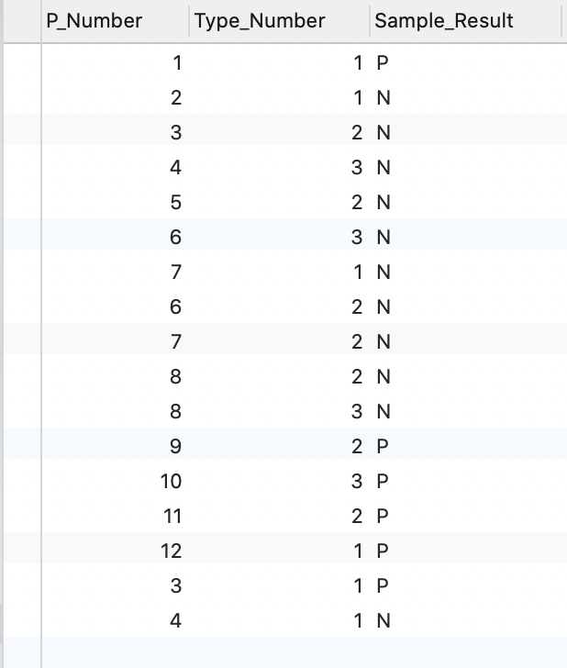

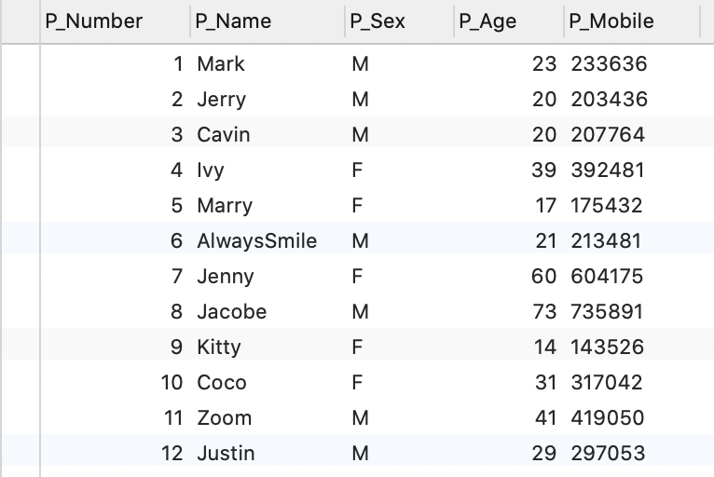

The result of the SELECT statement (screenshot):

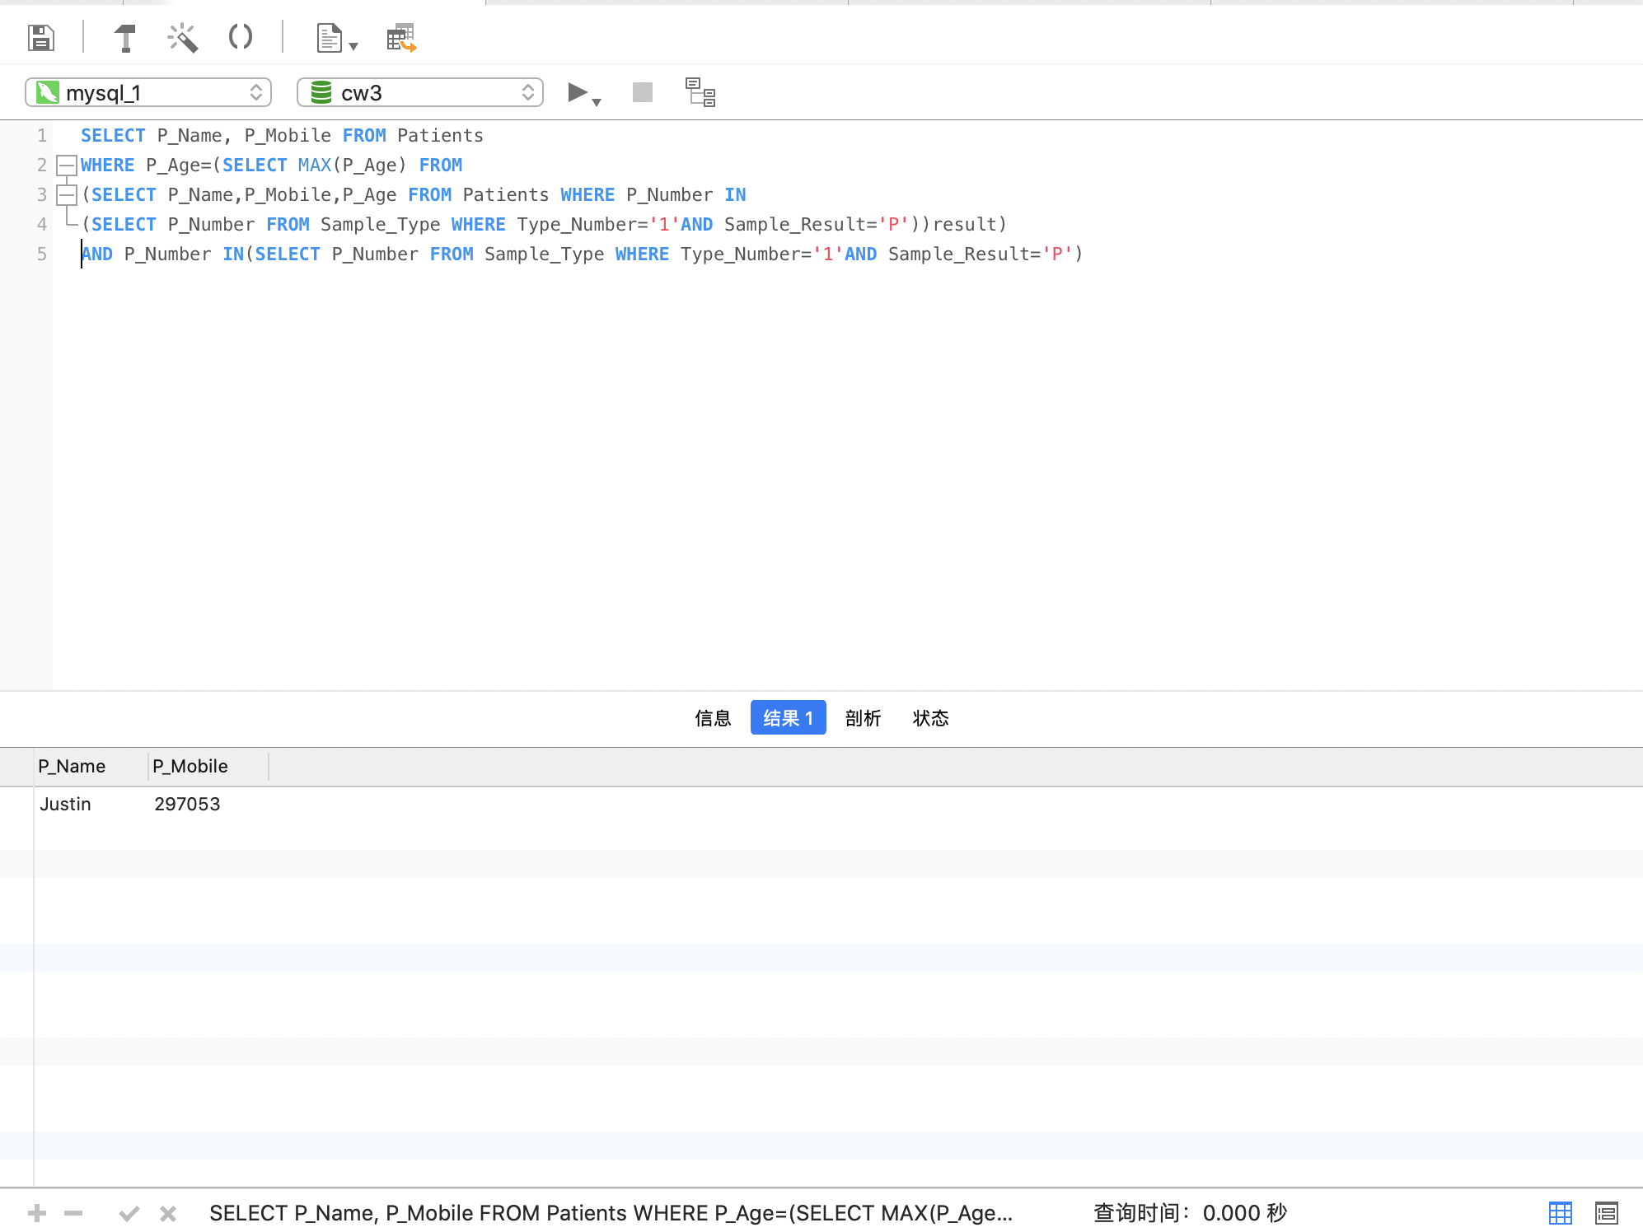

Use case 7: A medical specialist came to Central Lukewarm Kingdom Hospital and wanted to know the names and cell phone numbers of all the positive patients currently admitted to the Hospital so he could treat them.

Your SQL statement:

SELECT P_Name, P_Mobile FROM Patients WHERE

P_Number IN (SELECT result.P_Number FROM

(SELECT DISTINCT P_Number FROM Sample_Type WHERE Sample_Result='P')result,Time

WHERE Time.H_Number='1'AND result.P_Number=Time.P_Number)

Your test data and why it can prove that the SELECT statement works (Important! Please explain carefully): First, positive cases were screened from the ‘Sample_Type’ table: No. 1, 9, 10, 11 and 12. Then select the patients at Central Lukewarm Kingdom Hospital (No. 1, 10, 11 and 12) from the 'Time' table. Finally, the names and mobile phone numbers of these four Patients were screened out from the 'Patients' table and output.

The ‘Sample_Type’ table, ‘Time’ table and ‘Patients’ table are listed below:

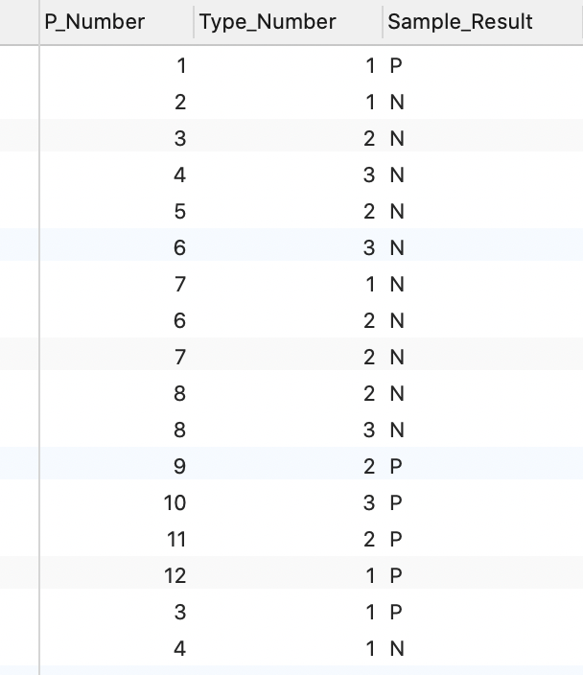

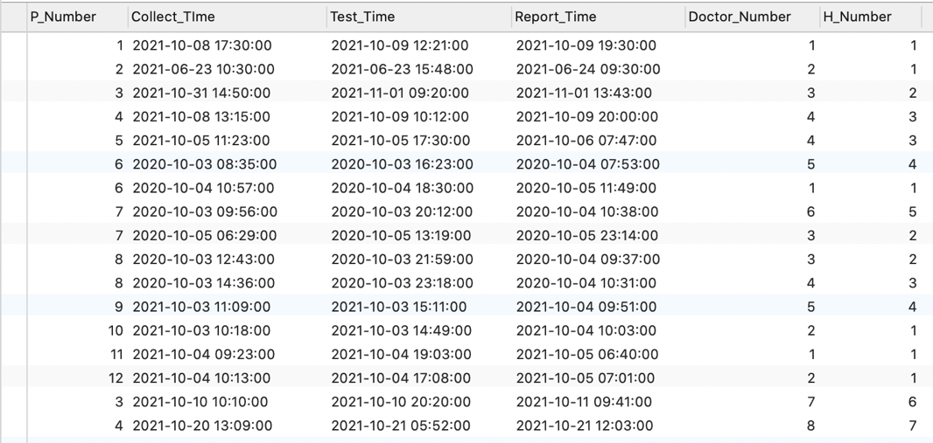

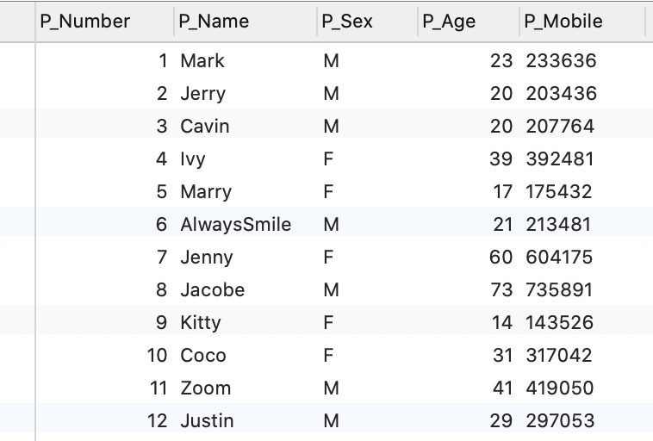

The result of the SELECT statement (screenshot):

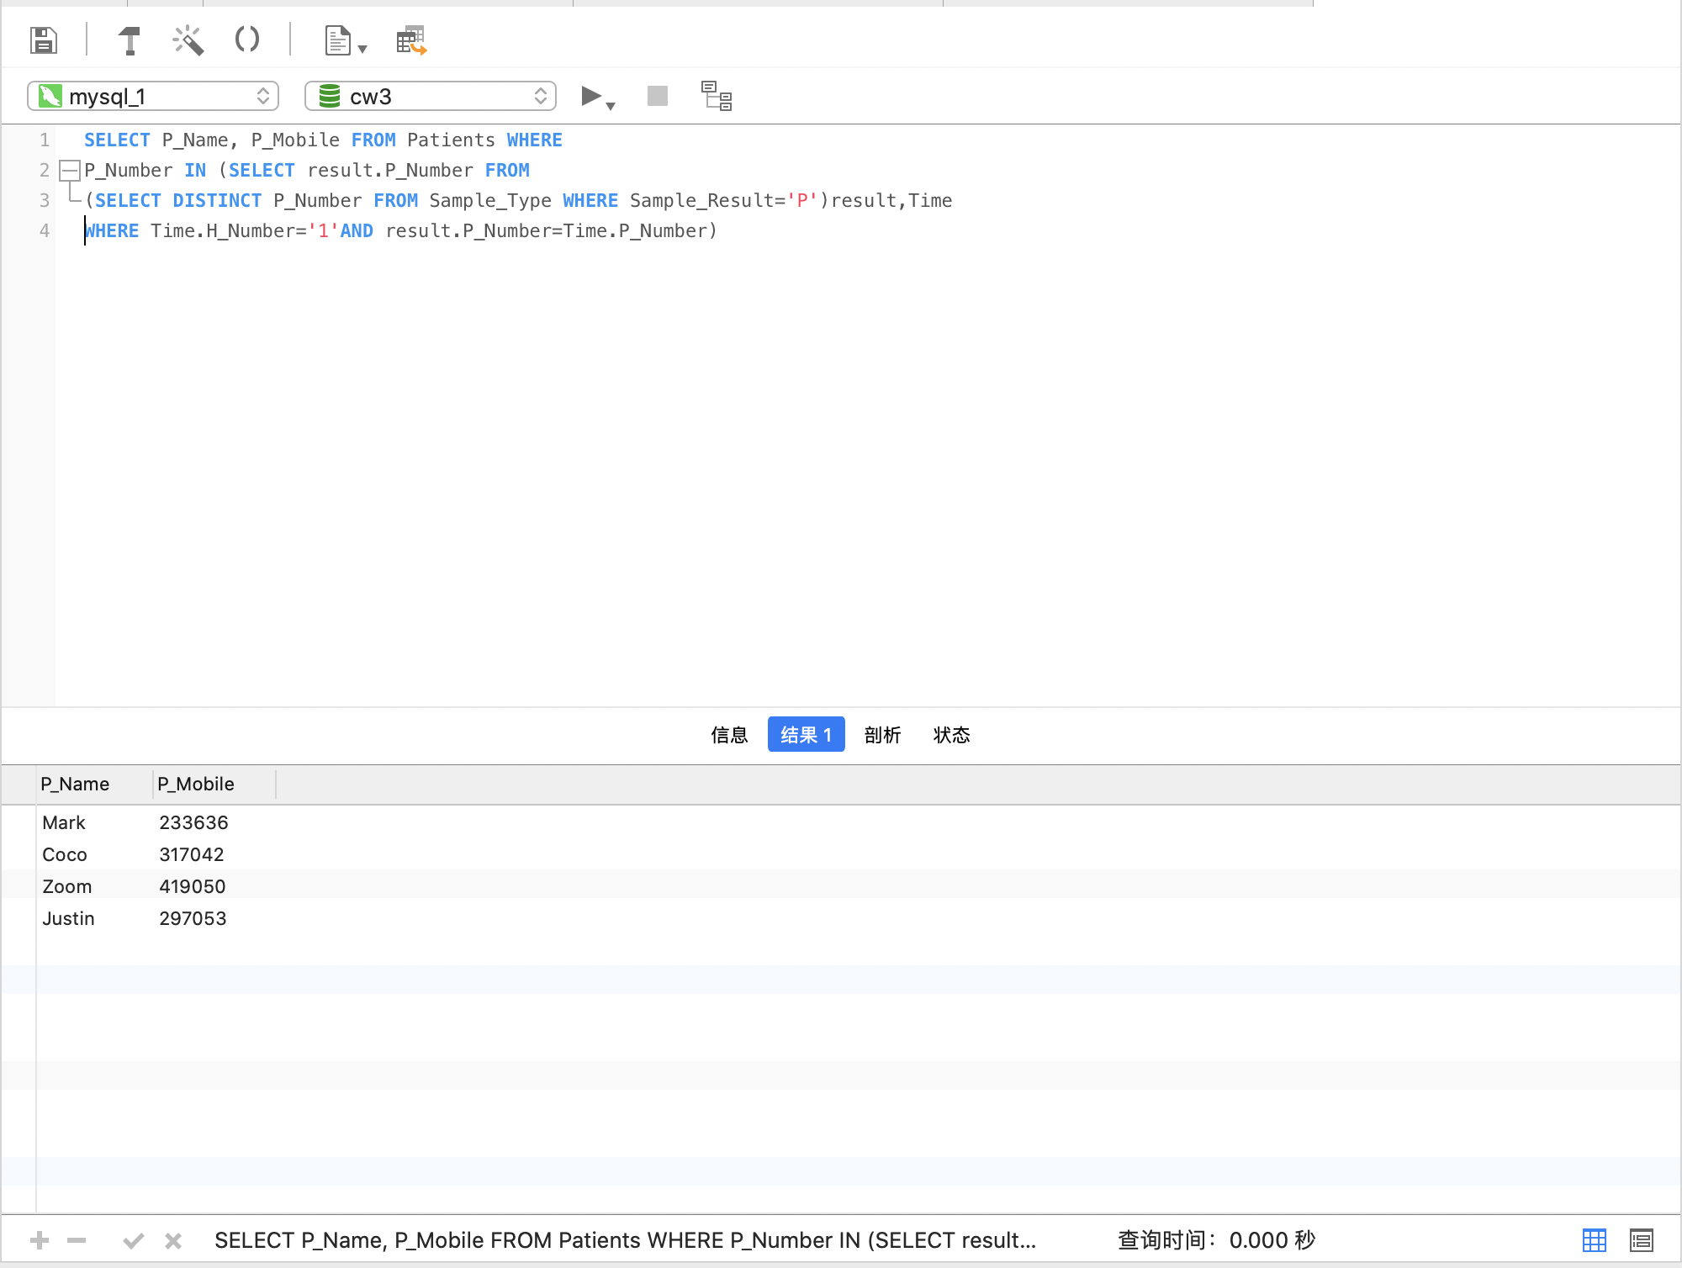

Use case 8: Now a new doctor(Bill) has arrived in Western Lukewarm Hillside. Please help him screen out the hospitals he can apply for and update the 'Doctor_information' table.

Your SQL statement:

UPDATE Doctor_information SET H_Number=(SELECT H_Number FROM Hospital INNER JOIN District USING (GPS) WHERE GPS='WI')WHERE Doctor_Name='Bill'

Your test data and why it can prove that the SELECT statement works (Important! Please explain carefully): Firstly, I use an INSERT statement to add the doctor's name to the 'Doctor_information' table. Then, I used the SELECT statement and INNER JOIN statement to filter out the hospital in Western Lukewarm Hillside (WI) and added its code to the 'Doctor_information' table via the UPDATE statement.

The ‘District’ table, ‘Hospital’ table and ‘Doctor_information’ table are listed below:

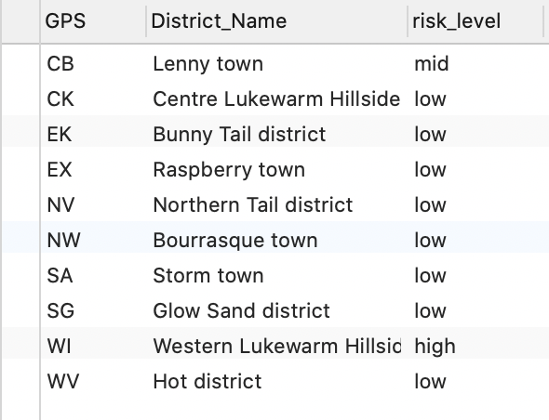

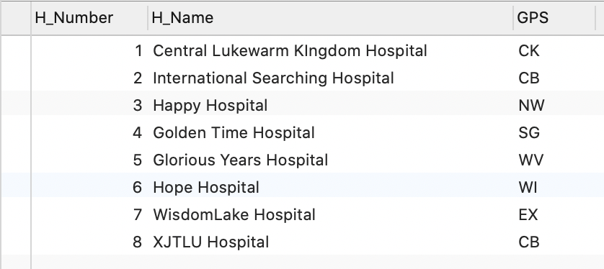

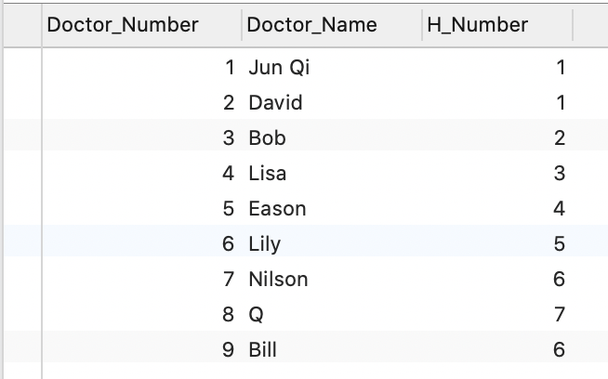

The result of the SELECT statement (screenshot):

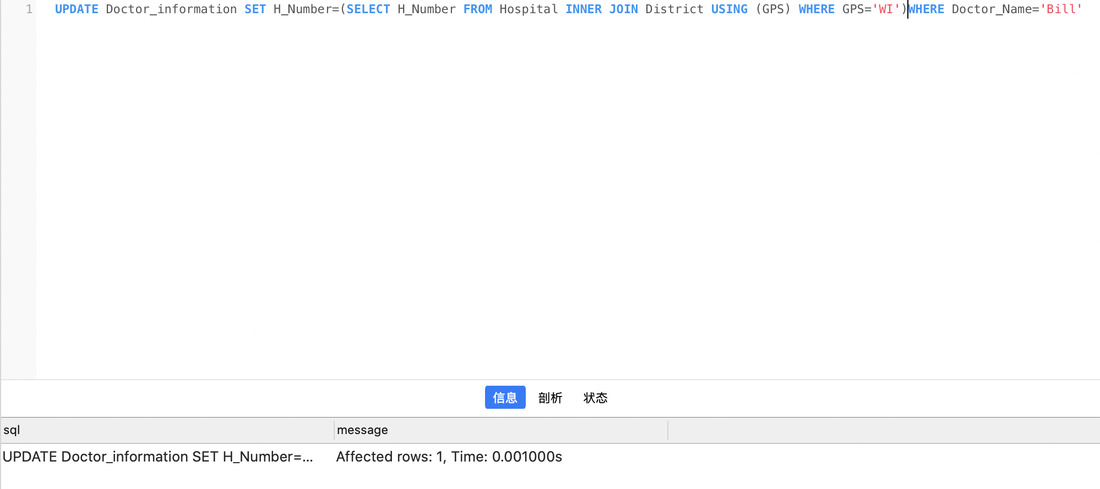

Use case 9: The coughid-21 virus has mutated (and is more dangerous for older adults). The government therefore requested the names and cell phone numbers of patients aged 40 and older who tested positive for Coughid-21 after October 5.

Your SQL statement:

SELECT P_Name,P_Mobile FROM Patients WHERE P_Number IN

(SELECT DISTINCT P_Number FROM

(SELECT P_Number FROM Patients INNER JOIN Sample_Type USING (P_Number)

WHERE Sample_Type.Type_Number='1' AND Sample_Type.Sample_Result='P')result INNER JOIN Time USING (P_Number)

WHERE Time.Collect_TIme>'2021-10-5-00:00') AND P_Age>40

Your test data and why it can prove that the SELECT statement works (Important! Please explain carefully): Firstly, the Patients infected with Coughid-21 (no. 1, 3 and 12) were screened from the 'Patients' and' Sample_Type 'tables using the INNER JOIN function. Then select the testing time after October 5th from the 'Time' table(no.1, 3). Finally, the Patients who met all the above requirements and were over 40 years old were found out from the 'Patients' table(no.3), and his name and mobile phone numbers were output.

The 'Patients' table, ' Sample_Type ' table and ‘Time’ table are listed below:

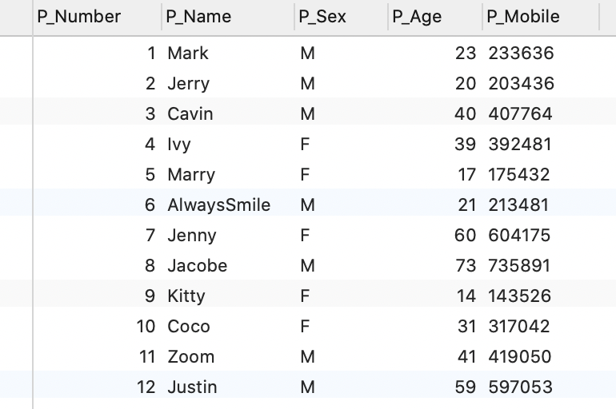

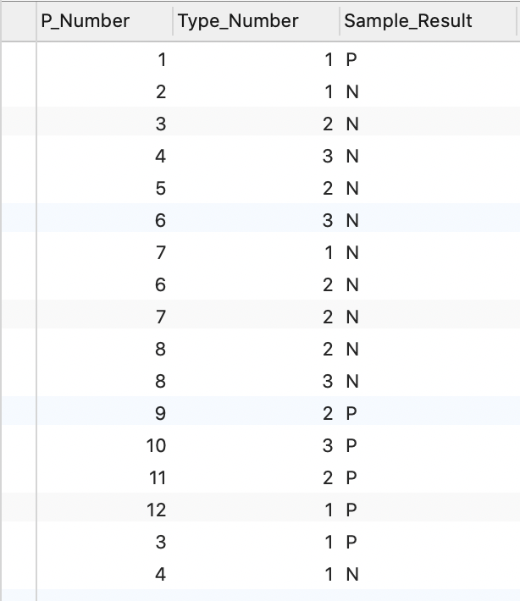

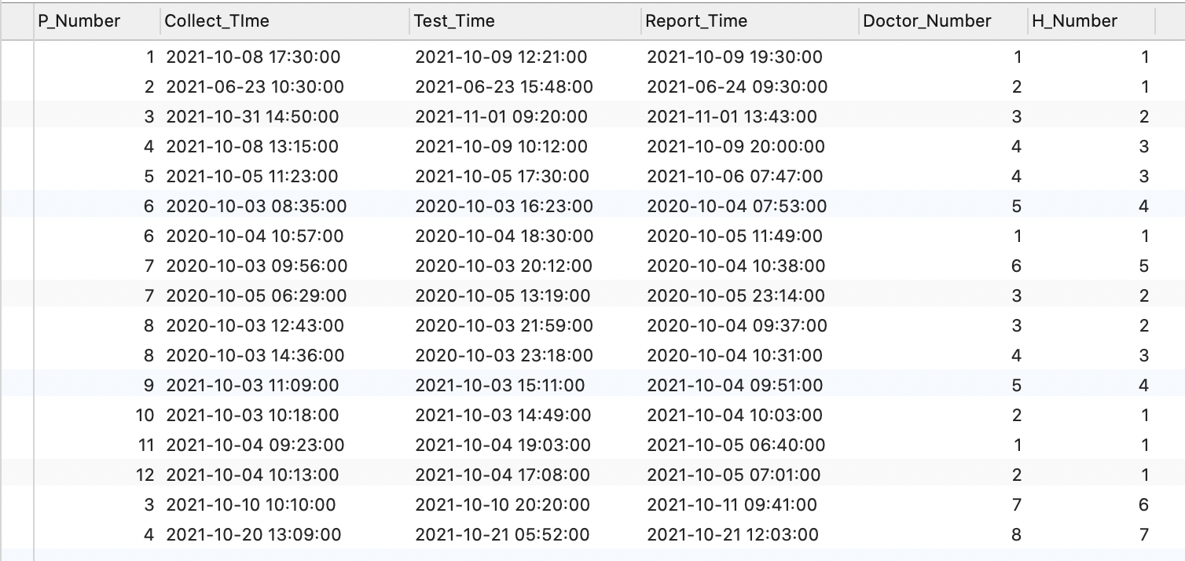

The result of the SELECT statement (screenshot):

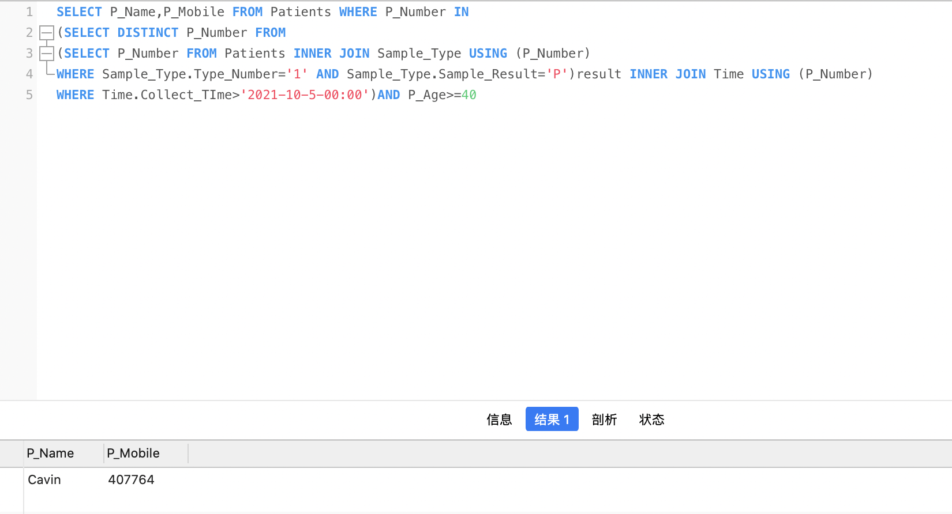

Use case 10: The government of Lenny town requires that doctors at all hospitals in the area be trained to deal with the mutated virus. Please write a query to find all the doctors at the hospitals in the area.

Your SQL statement:

SELECT Doctor_Name FROM Doctor_information WHERE H_Number IN

(SELECT H_Number FROM Hospital WHERE GPS=(SELECT GPS FROM District WHERE District_Name='Lenny town'))

Your test data and why it can prove that the SELECT statement works (Important! Please explain carefully): Firstly, find the GPS code (CB) corresponding to Lenny Town from the 'District' table. Then, from the 'Hospital' table, find the codes for hospitals in that area (no. 2 and 8). Finally, find the names of the doctors who work in these two hospitals from the 'Doctor_information' table.

The ‘District’ table, ‘Hospital’ table and ‘Doctor_information’ table are listed below:

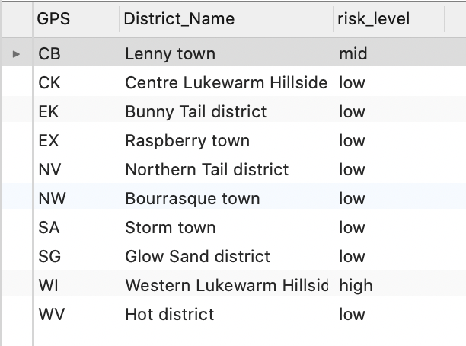

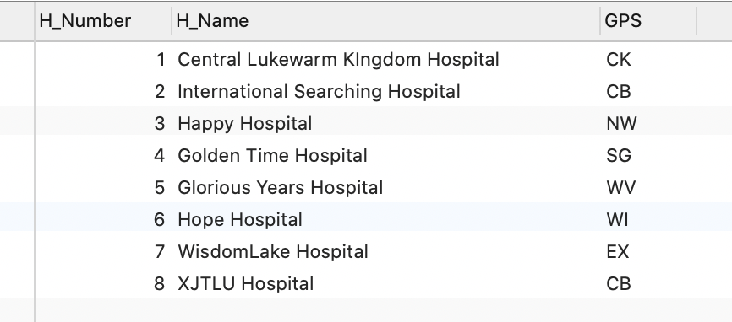

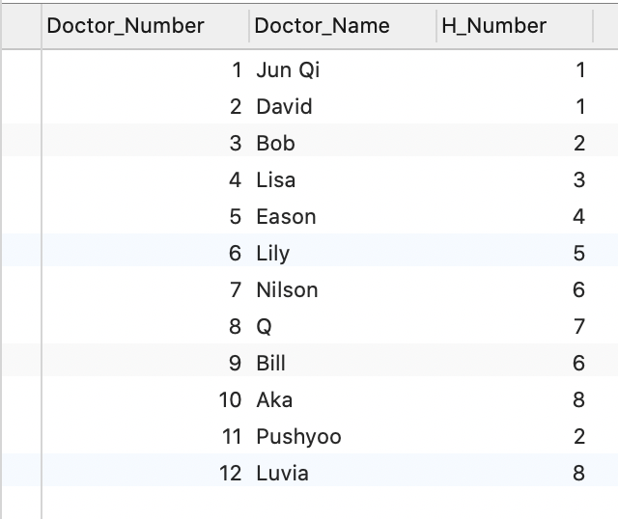

The result of the SELECT statement (screenshot):

